**AUTHOR PORTFOLIO**

First we styled header and footer according to our requirement

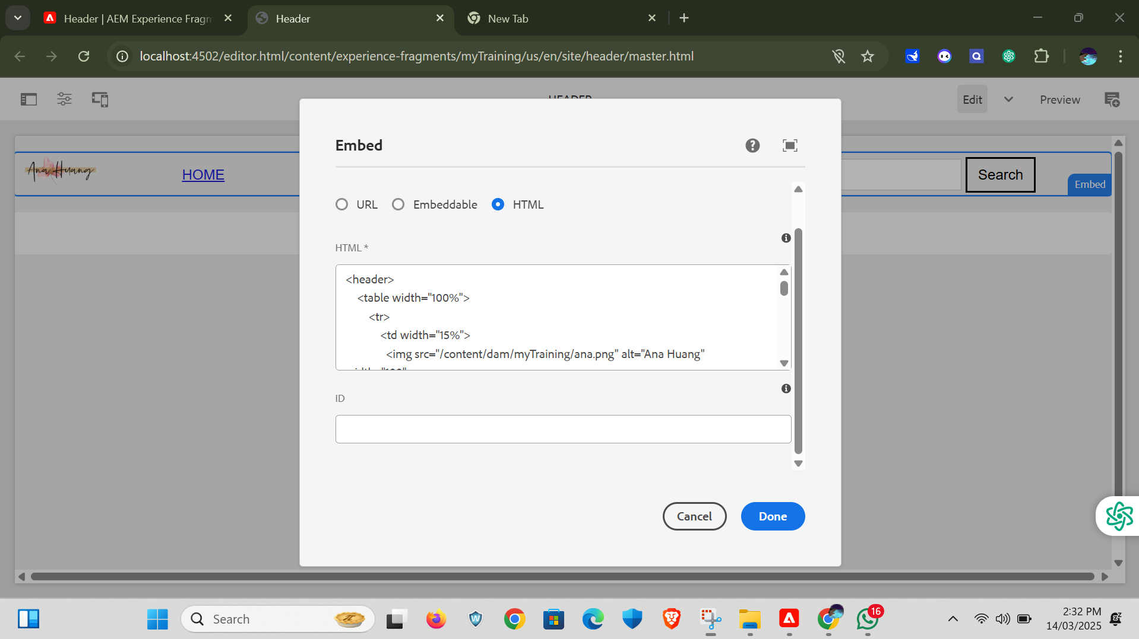

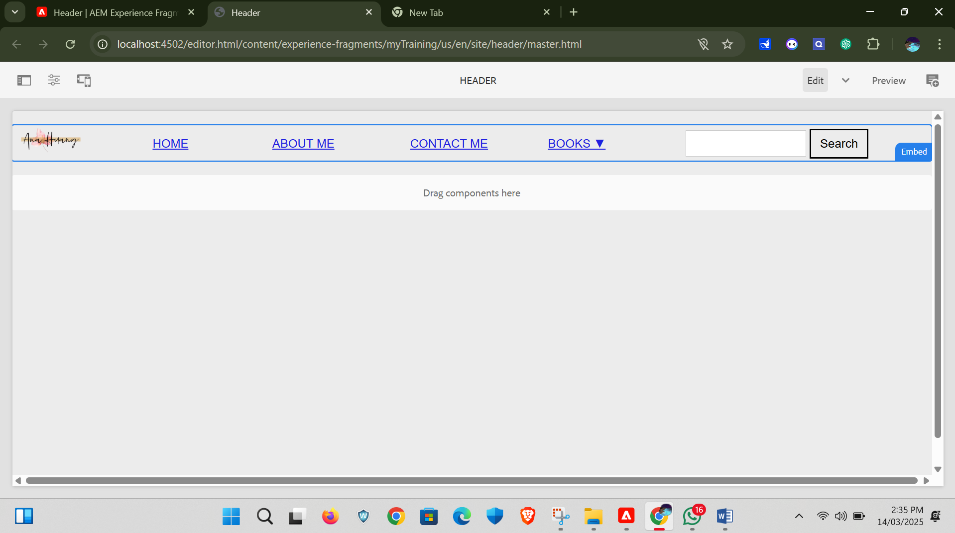

Footer

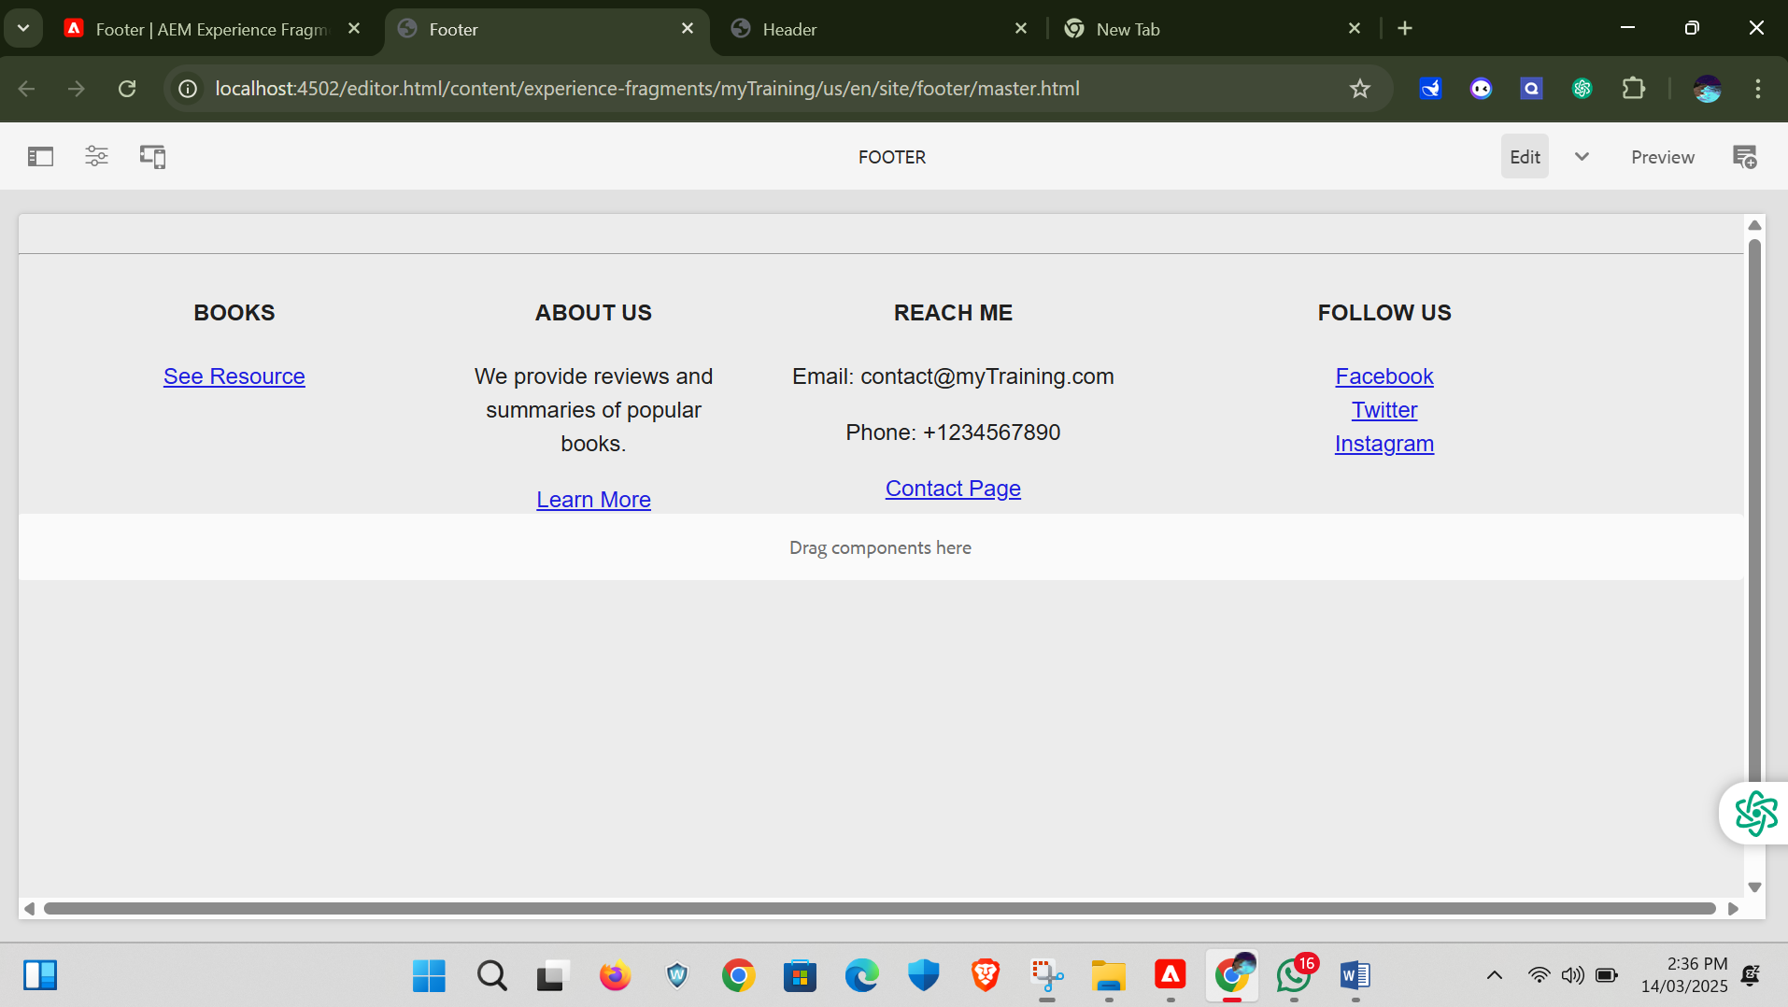

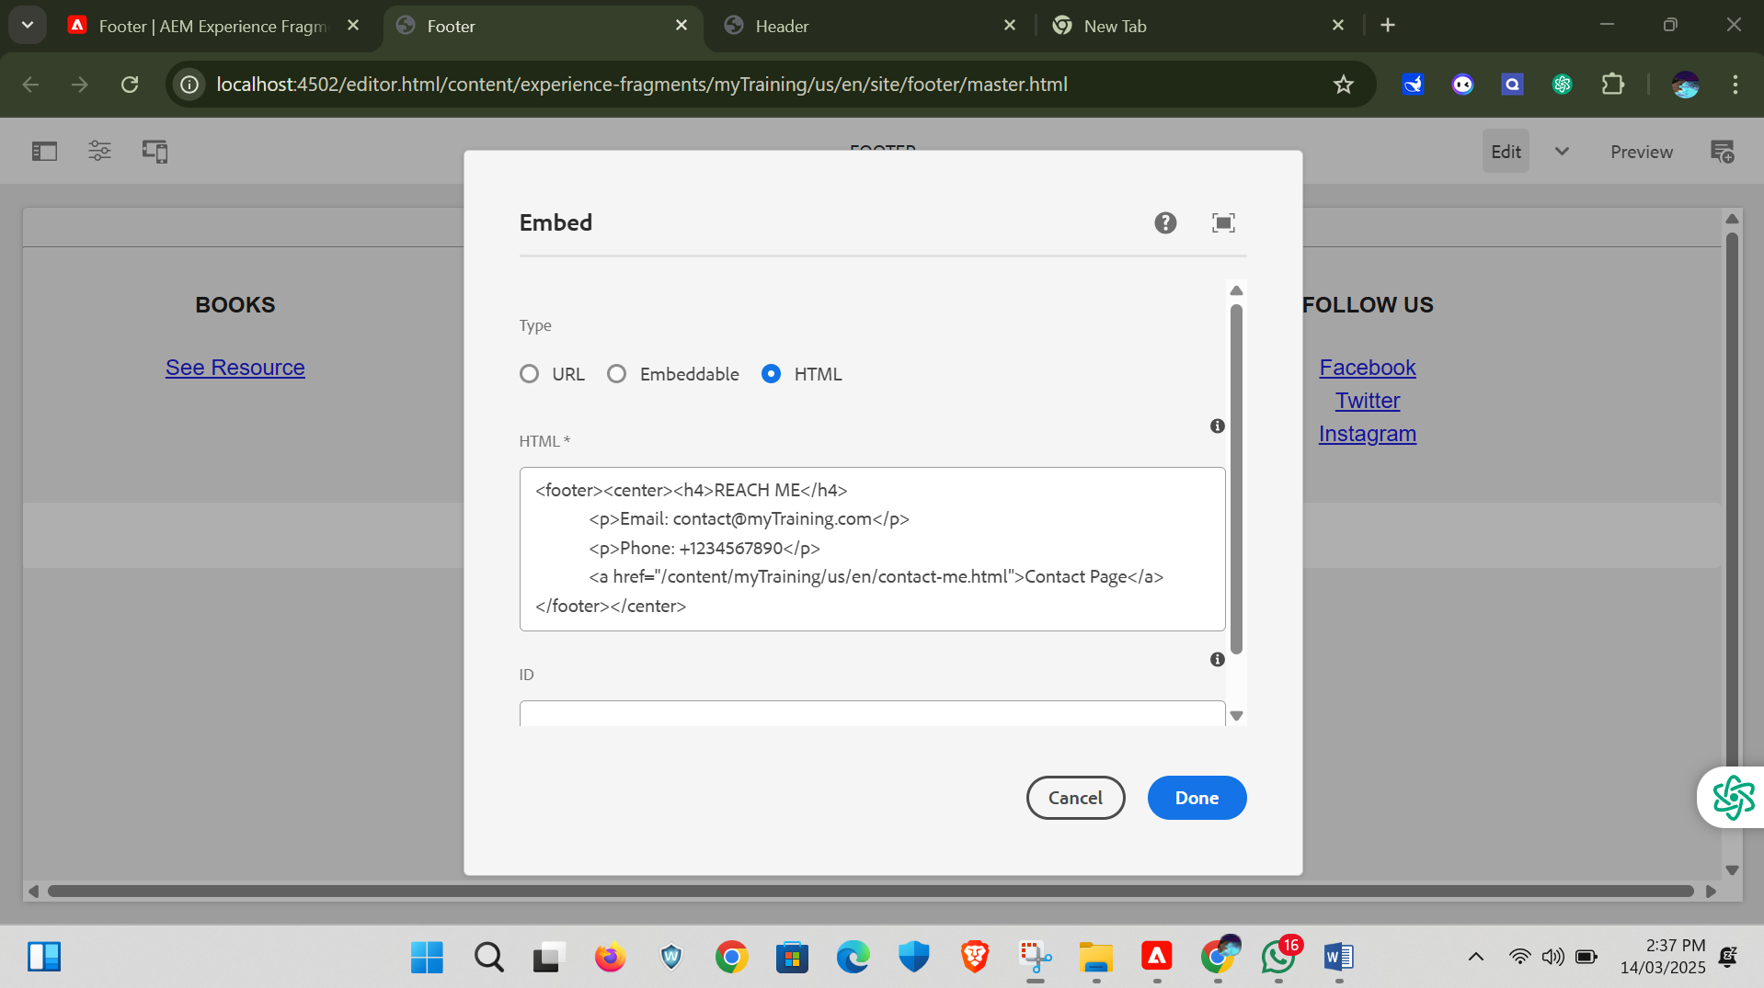

The server for the cards and card inside content

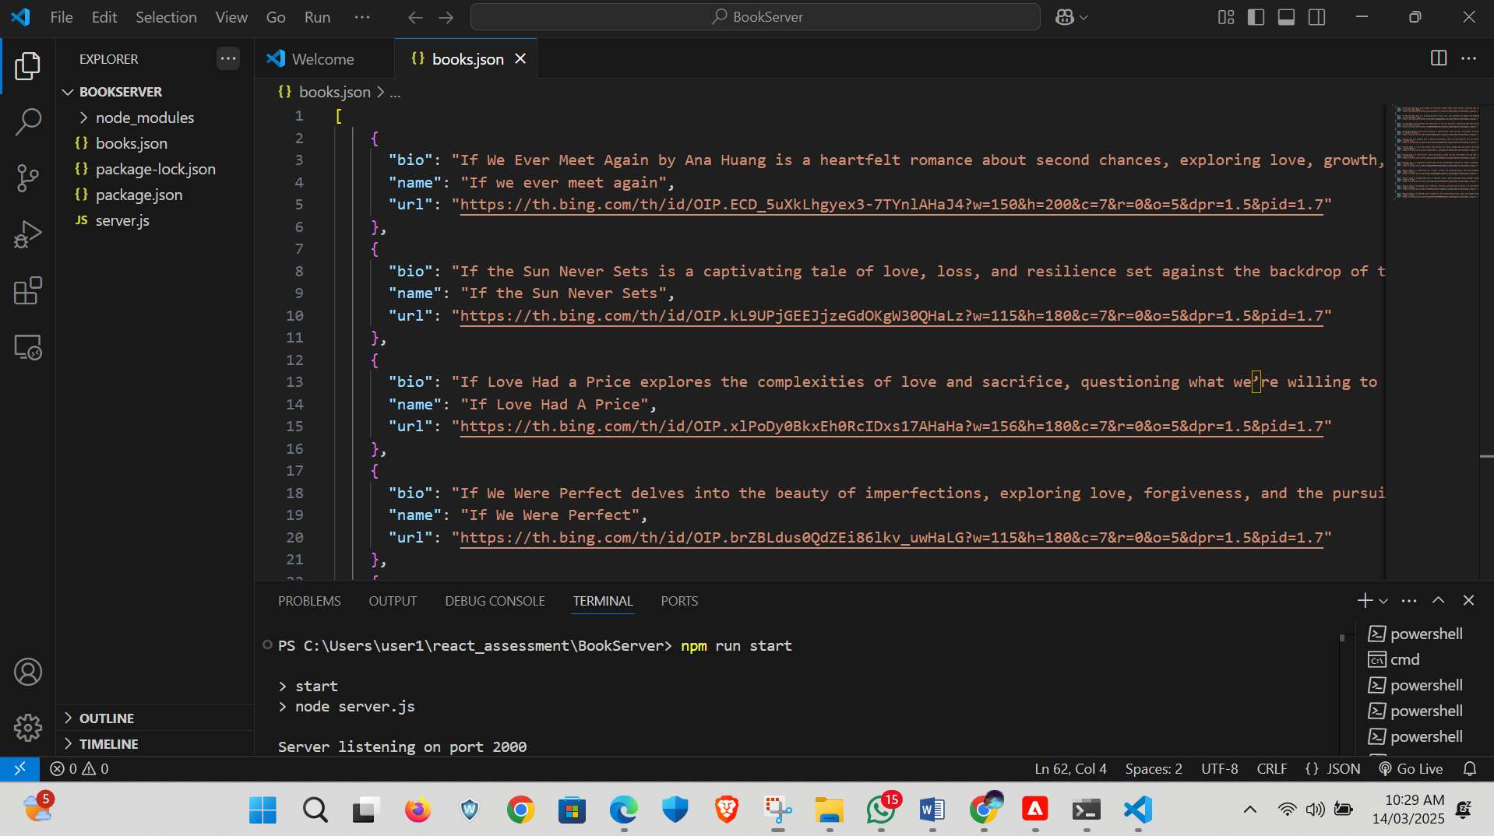

We can provide the link to the localhost server to fetch data were provided in the site.js

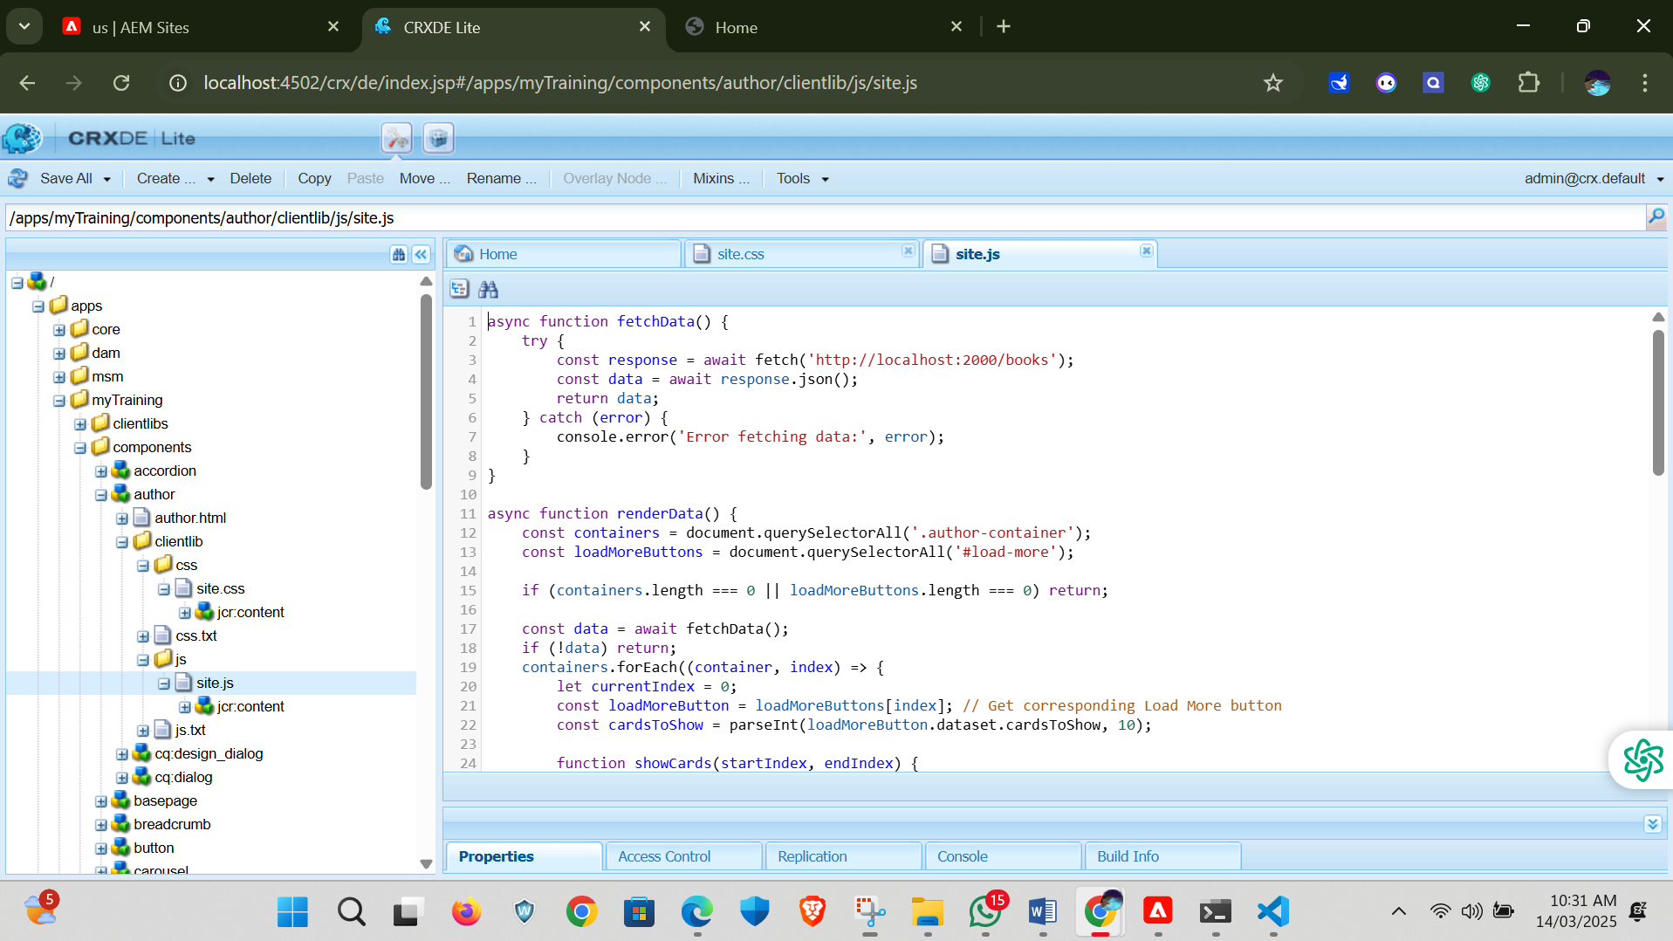

As we were needed to create a author’s portfolio we need to create template and pages here I provide the structure for this portfolio.

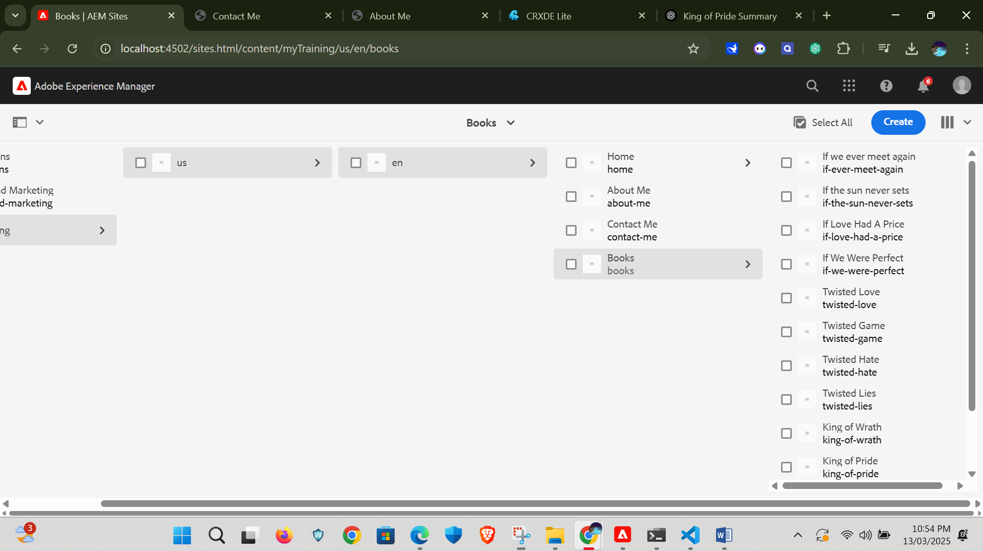

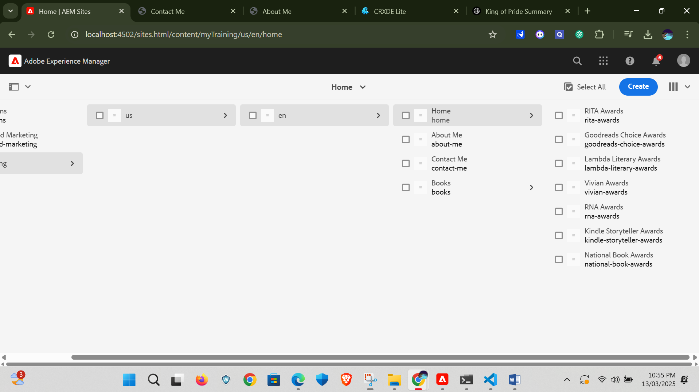

Here after creating a proper structure for creating portfolio we need to work on every page based on the content.

When we goes to en editable page it is the front page as it is the author portfolio as the reader can exploit more about the author and also about their work.

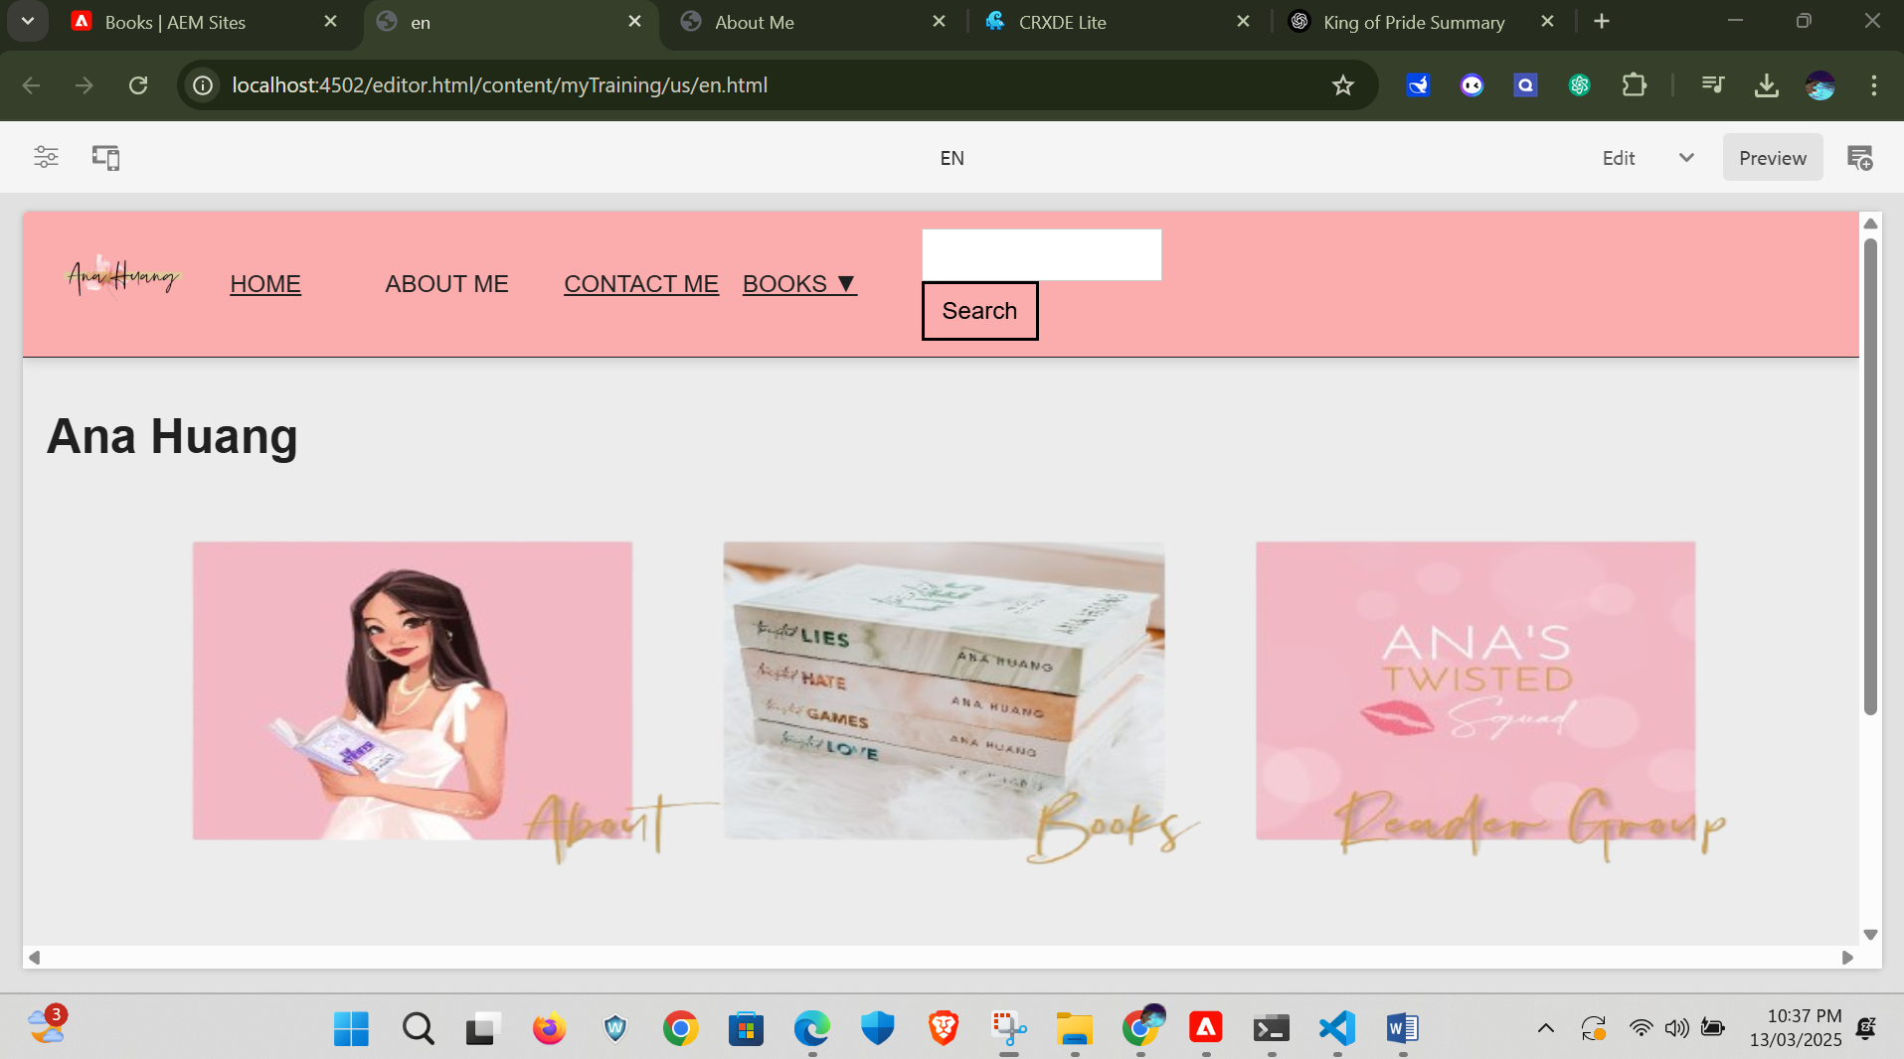

Its home page where we displayed the award which were received by our author.

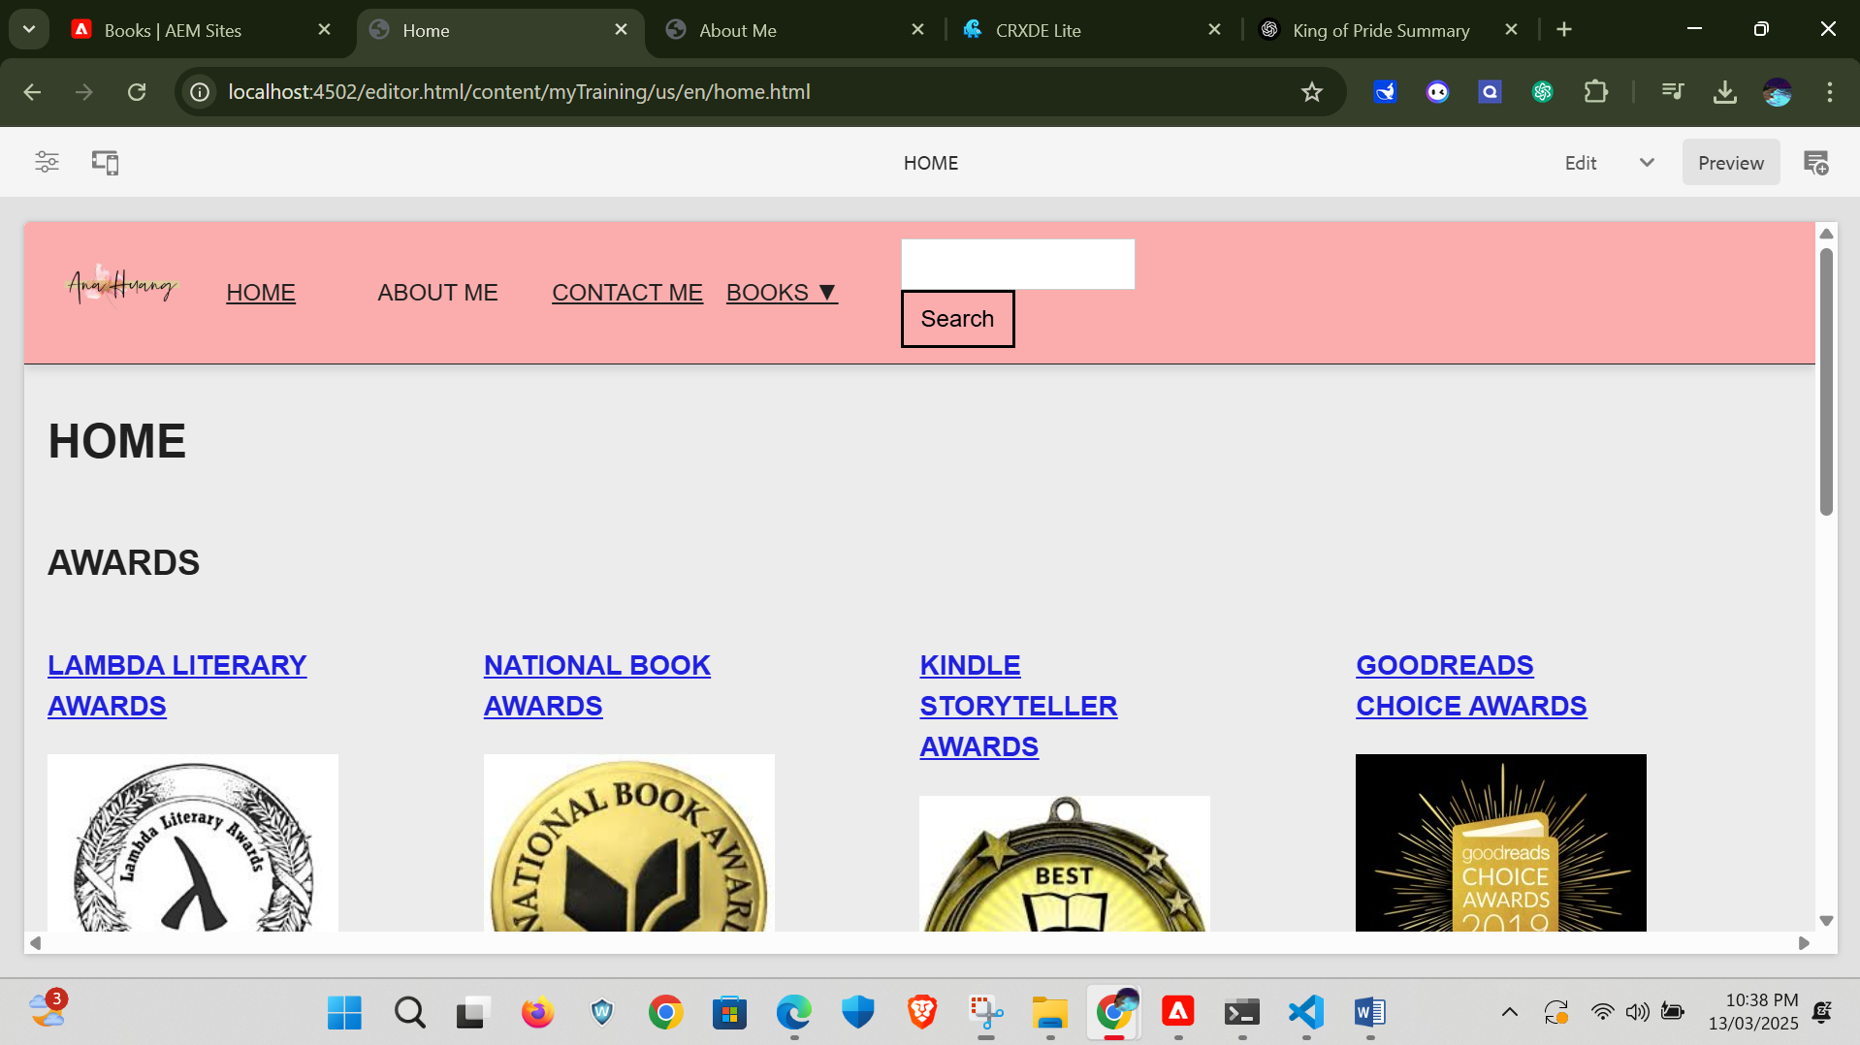

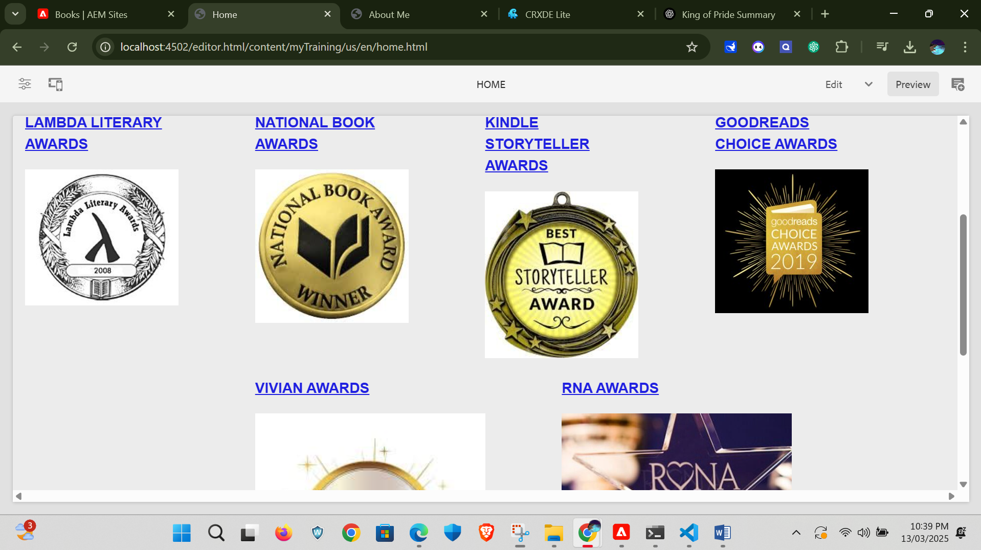

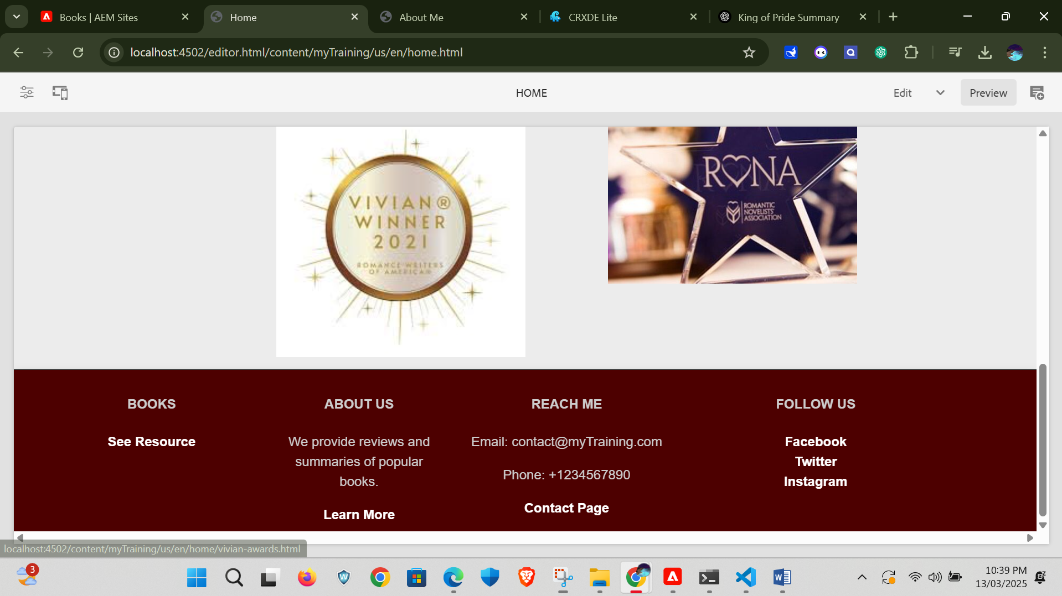

In this award page each award picture were connect with a separate page with its description and about the award for what book that the author received her award where provided descriptively in that page when we click on the award picture or title it navigate to that award description page.

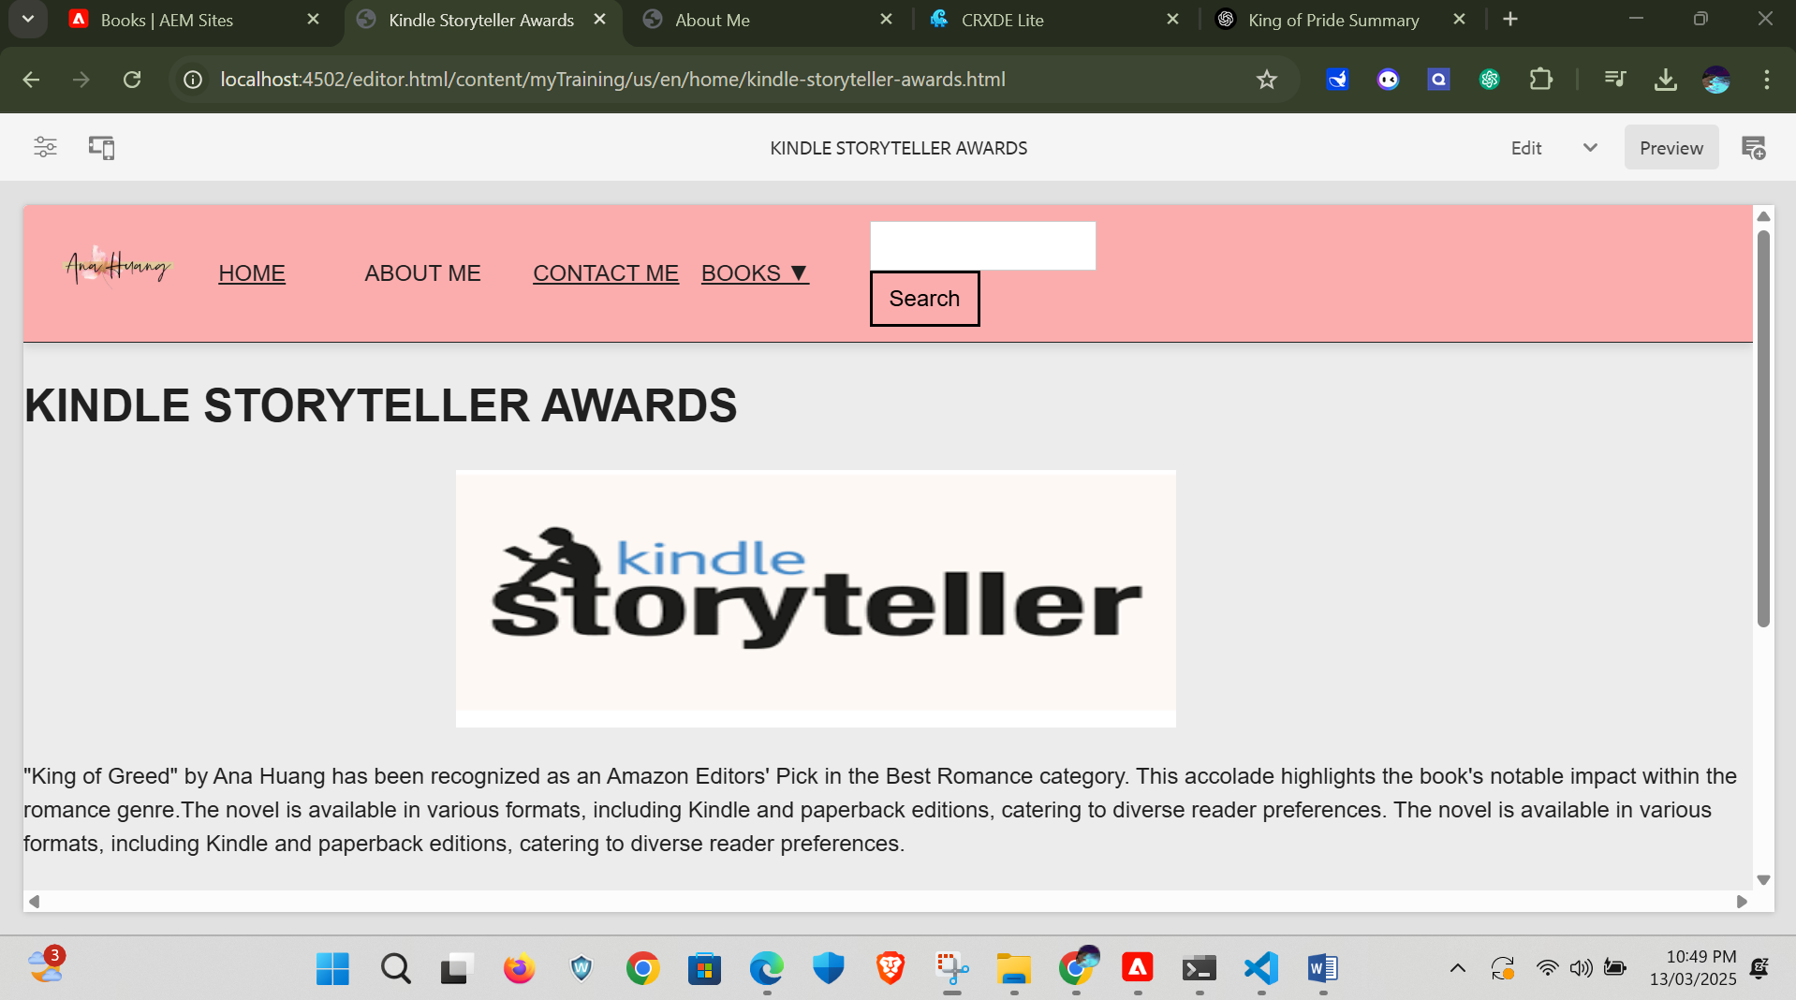

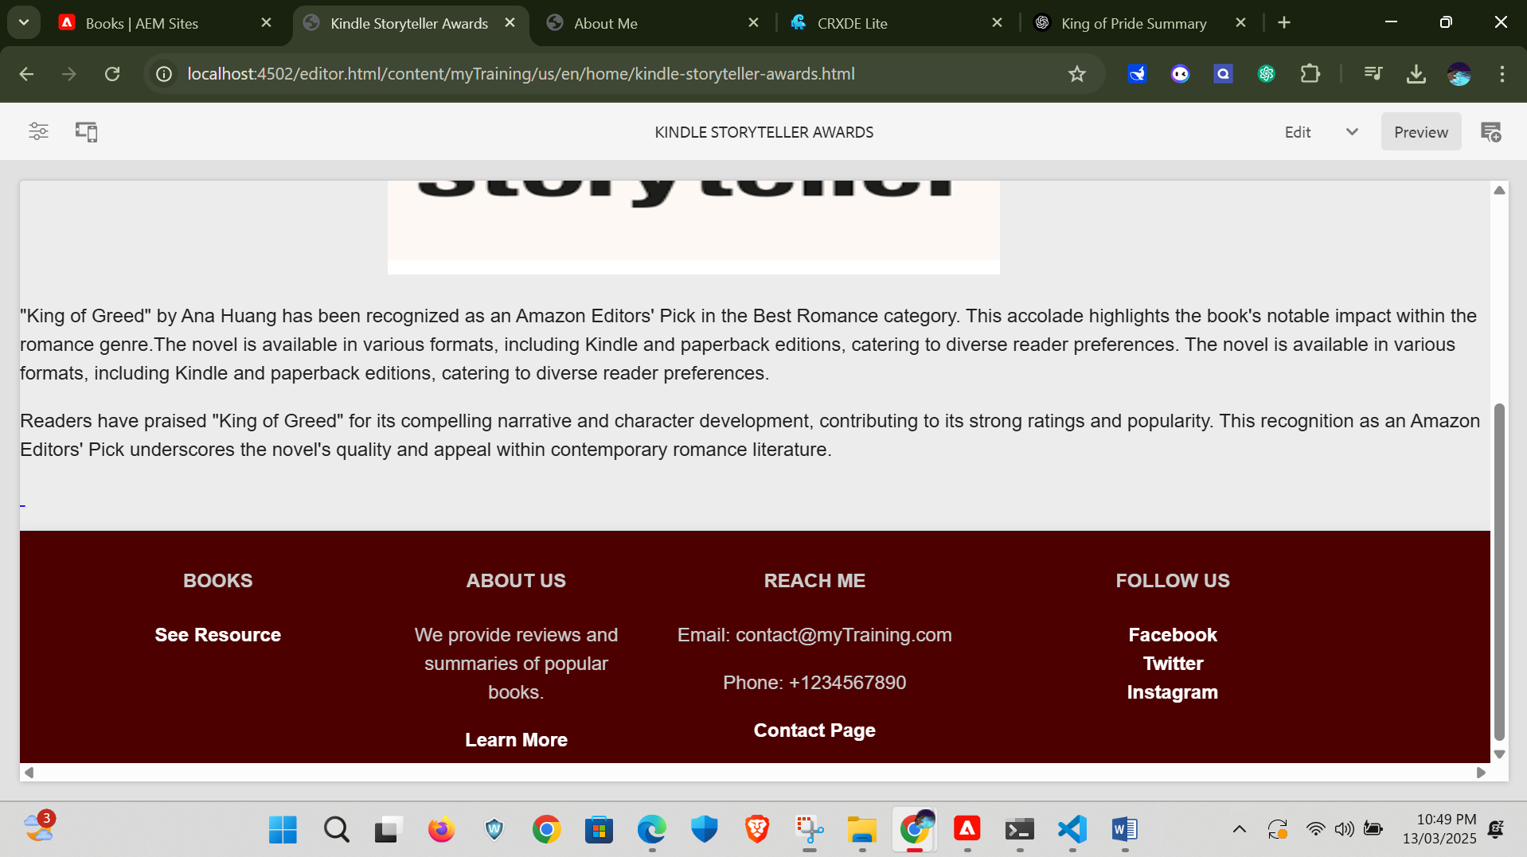

Here it attach a second example for that award page

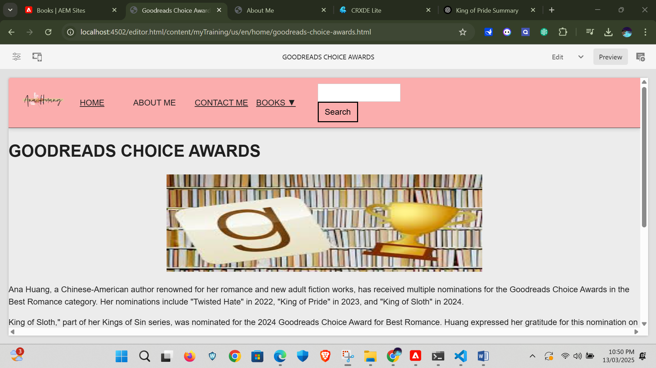

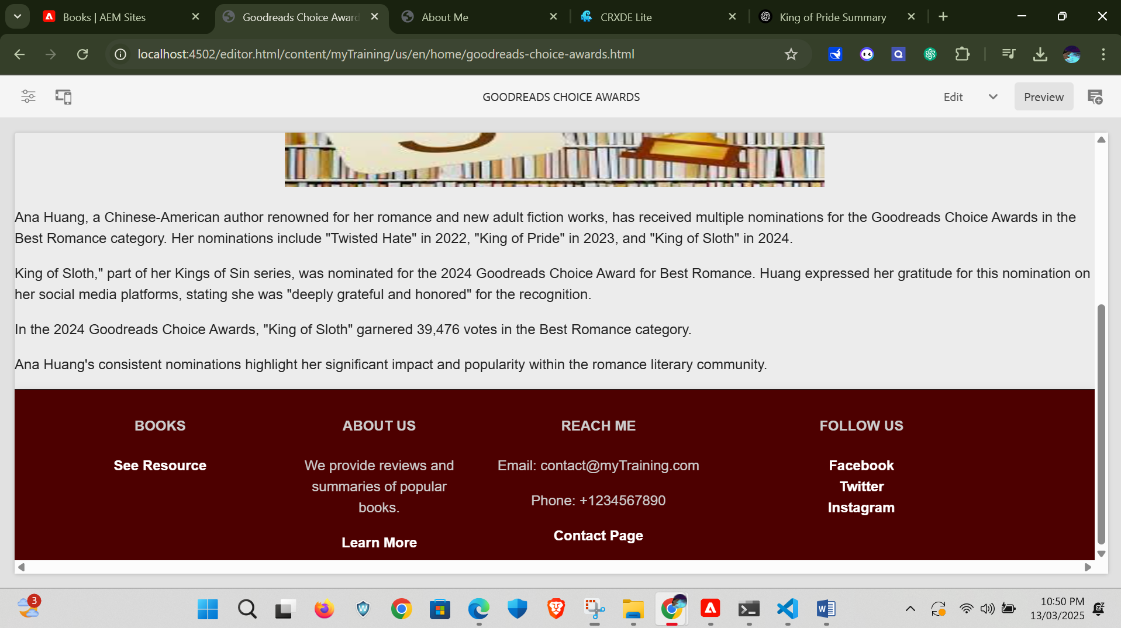

Next is we are going to about me page of the author with clear description of the author and her achievements with her profile picture and also with the message from author all will be placed here in this page.

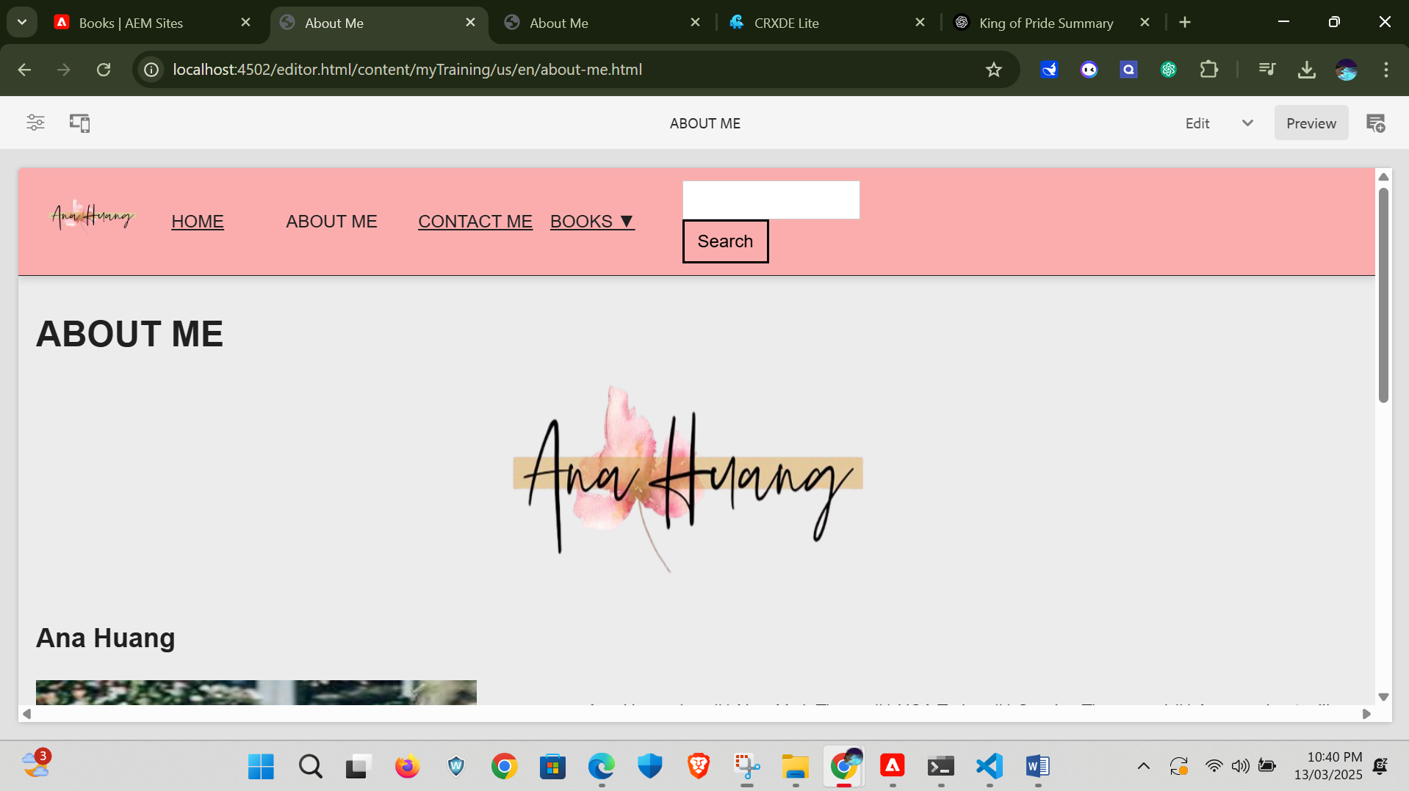

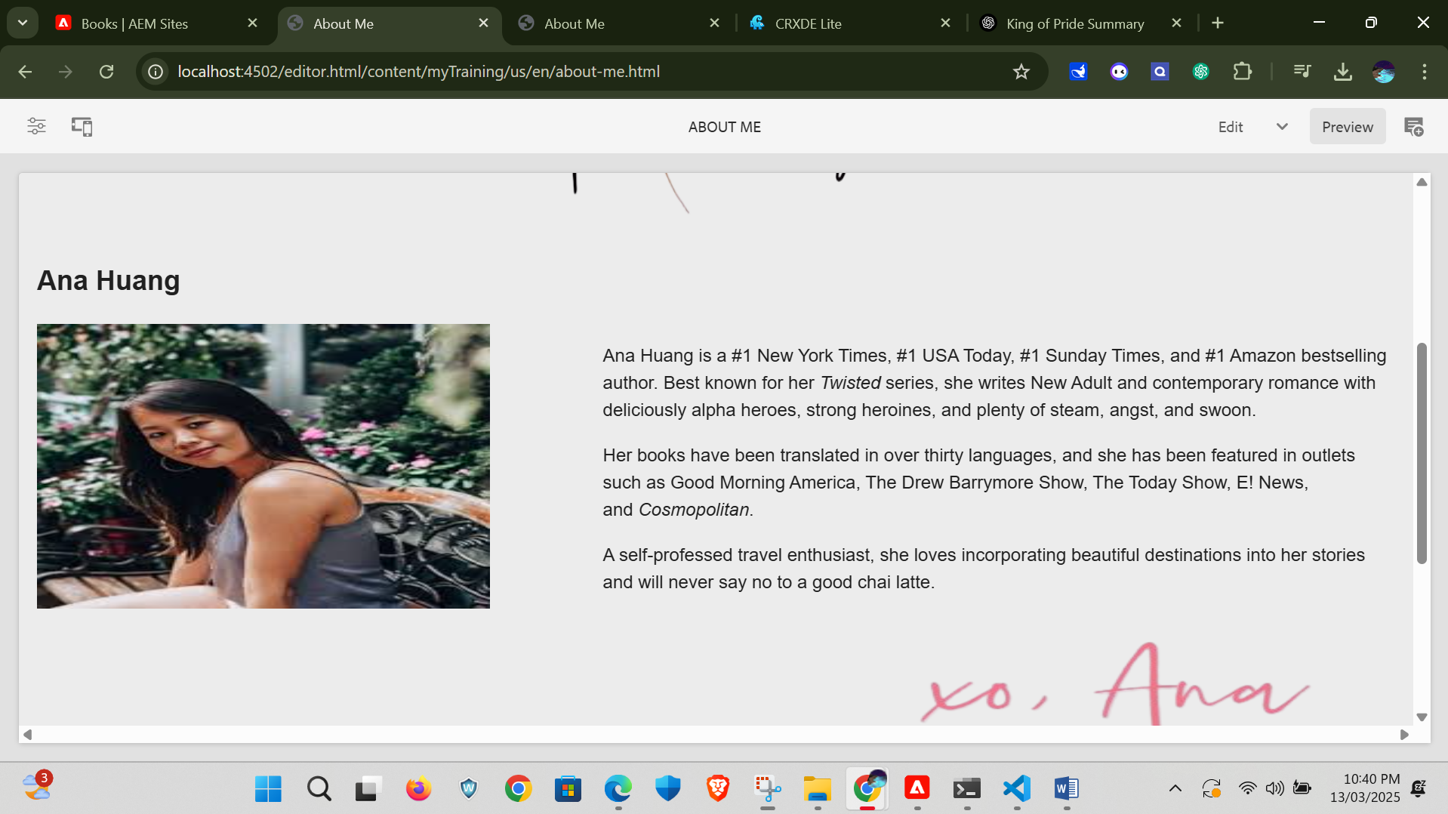

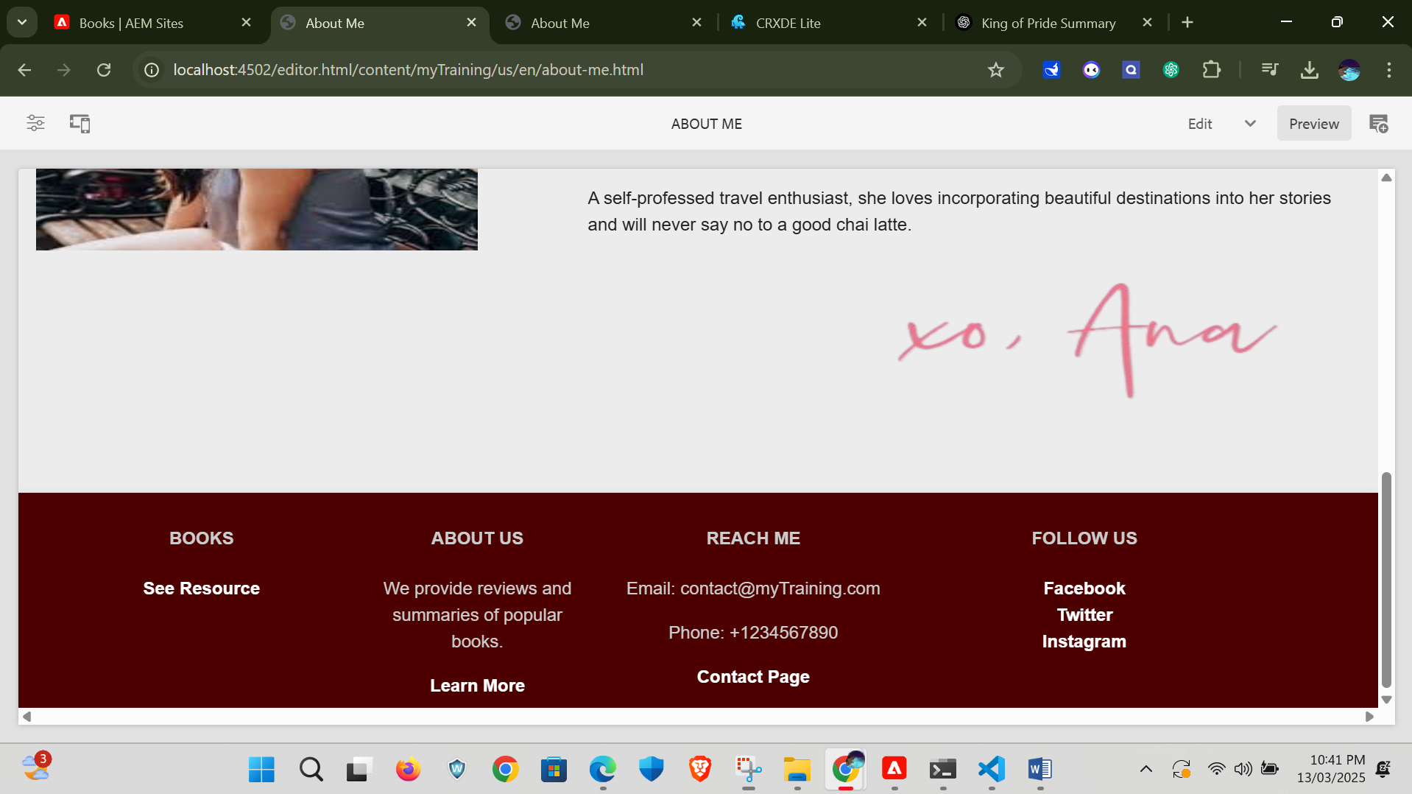

We can also navigate to about me page with the learn more link which is attached in the footer.

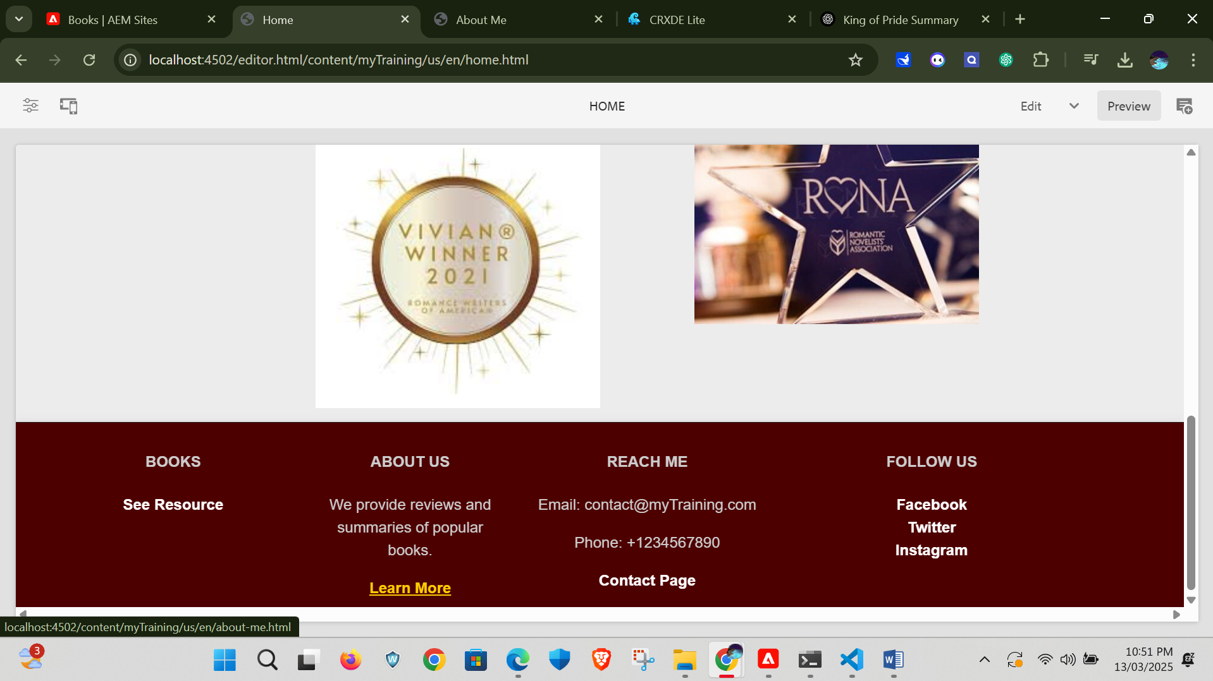

Here is the nextpage which is contact me page where there is detailed contact info of author based on the requiements and also it have link to their publishing company etc and also her own website facebook and Instagram link.

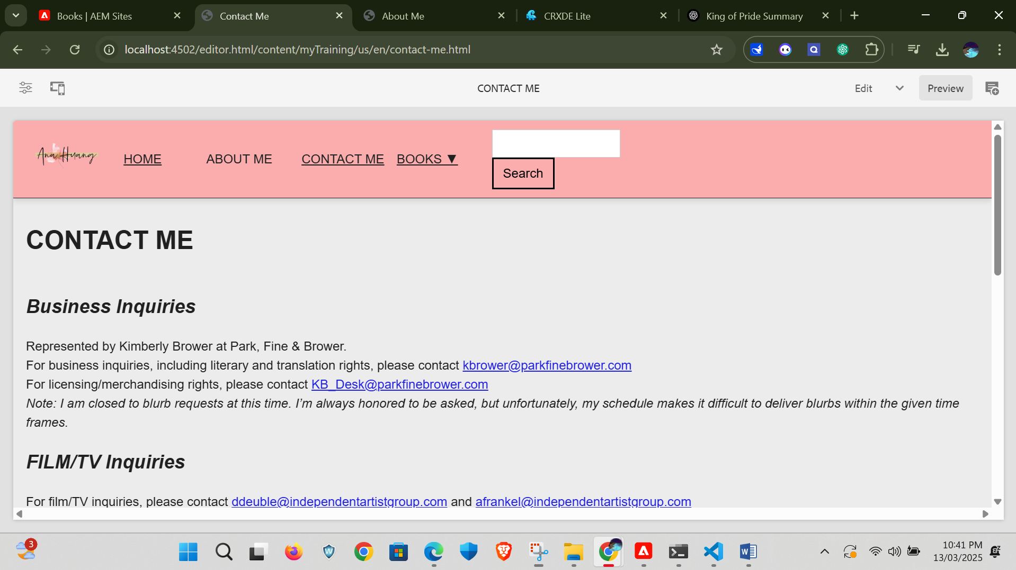

If we want to navigate to this page directly through the link placed in the footer.

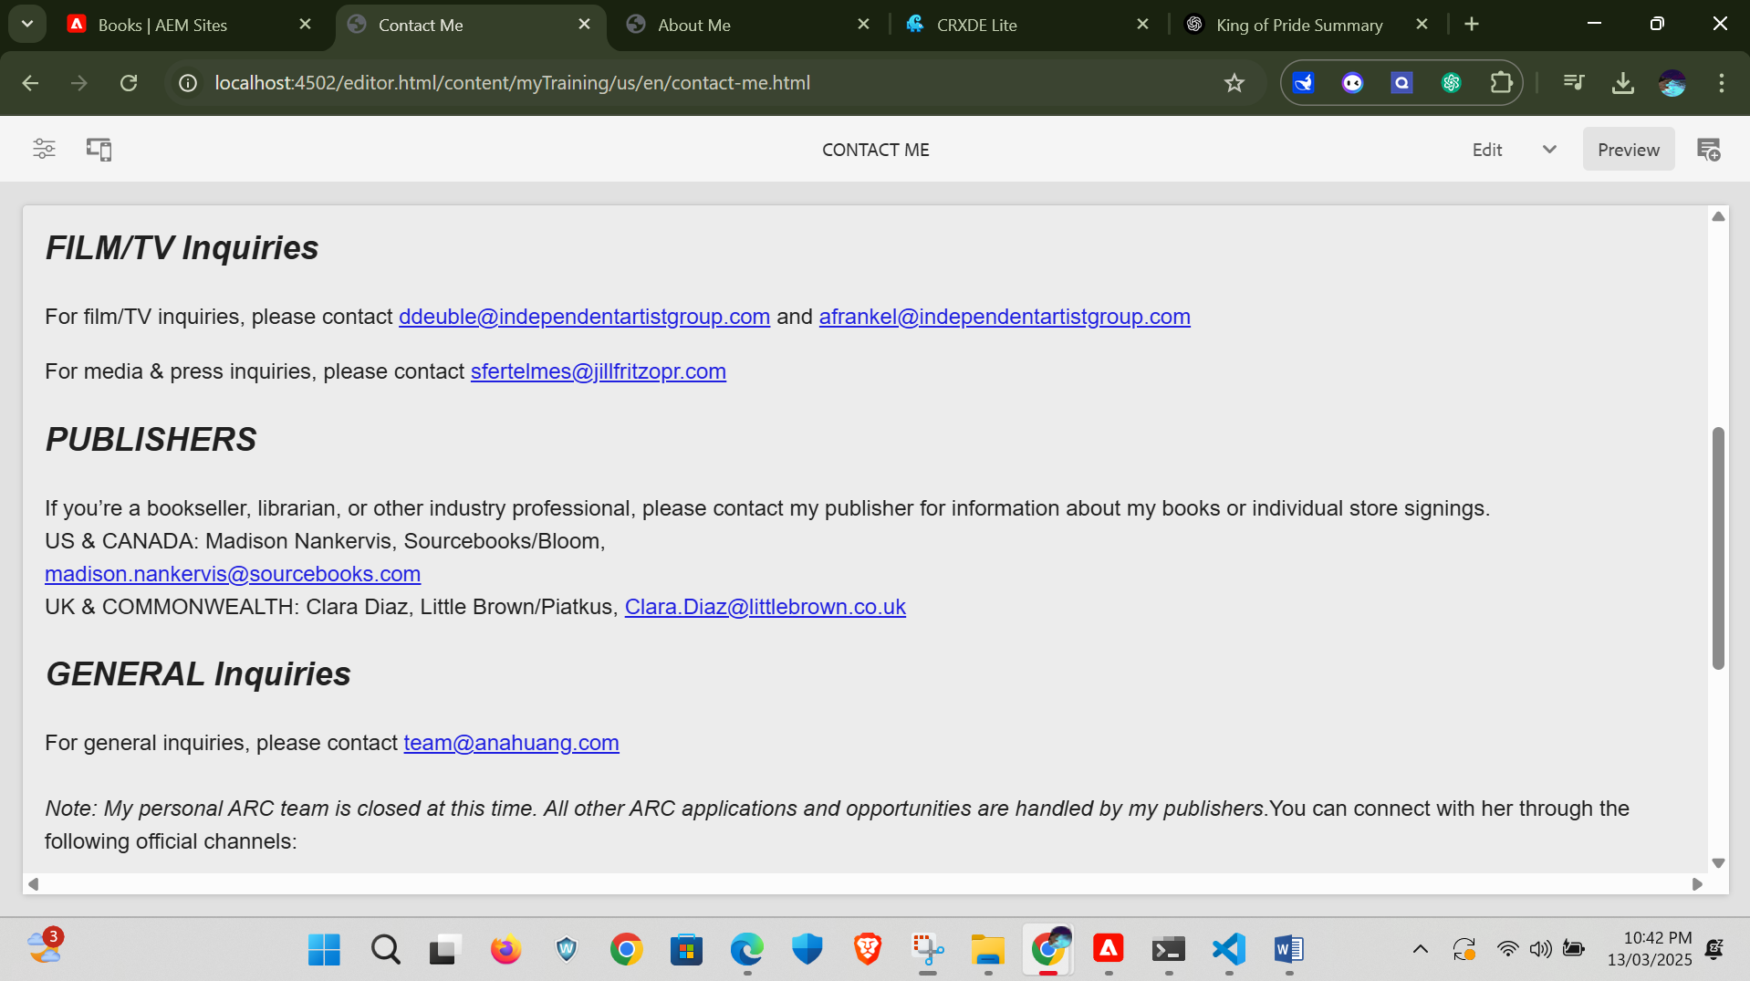

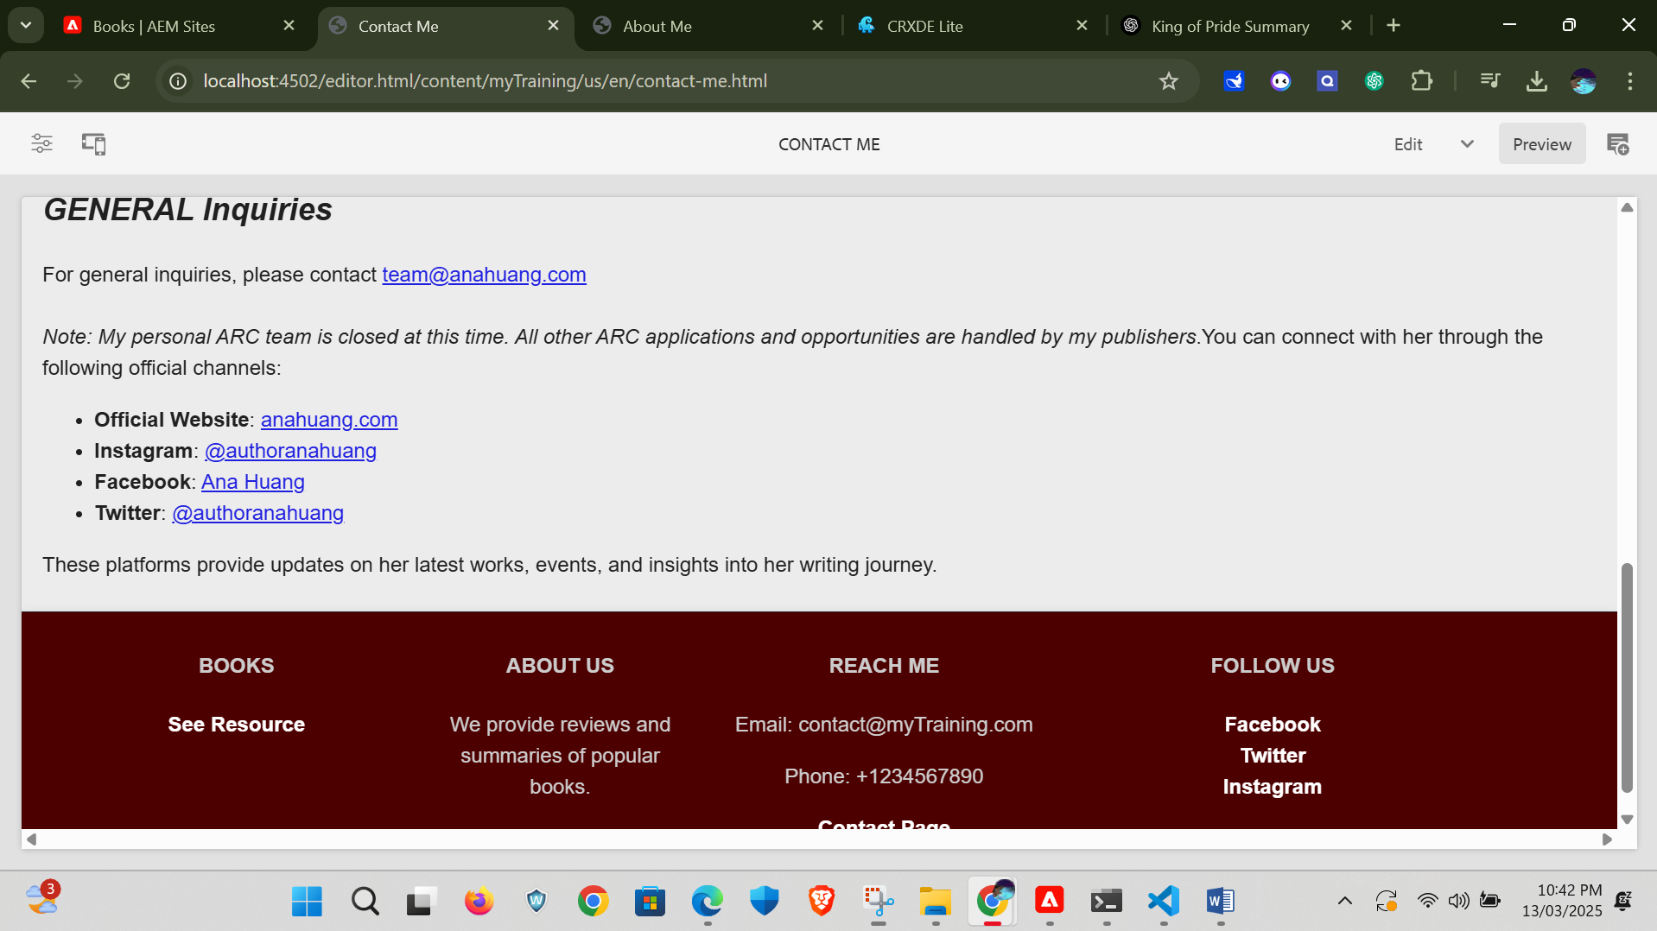

As we attach the authors original website link when we click on official website link we provided in the contact me page we will navigate to author’s original page.

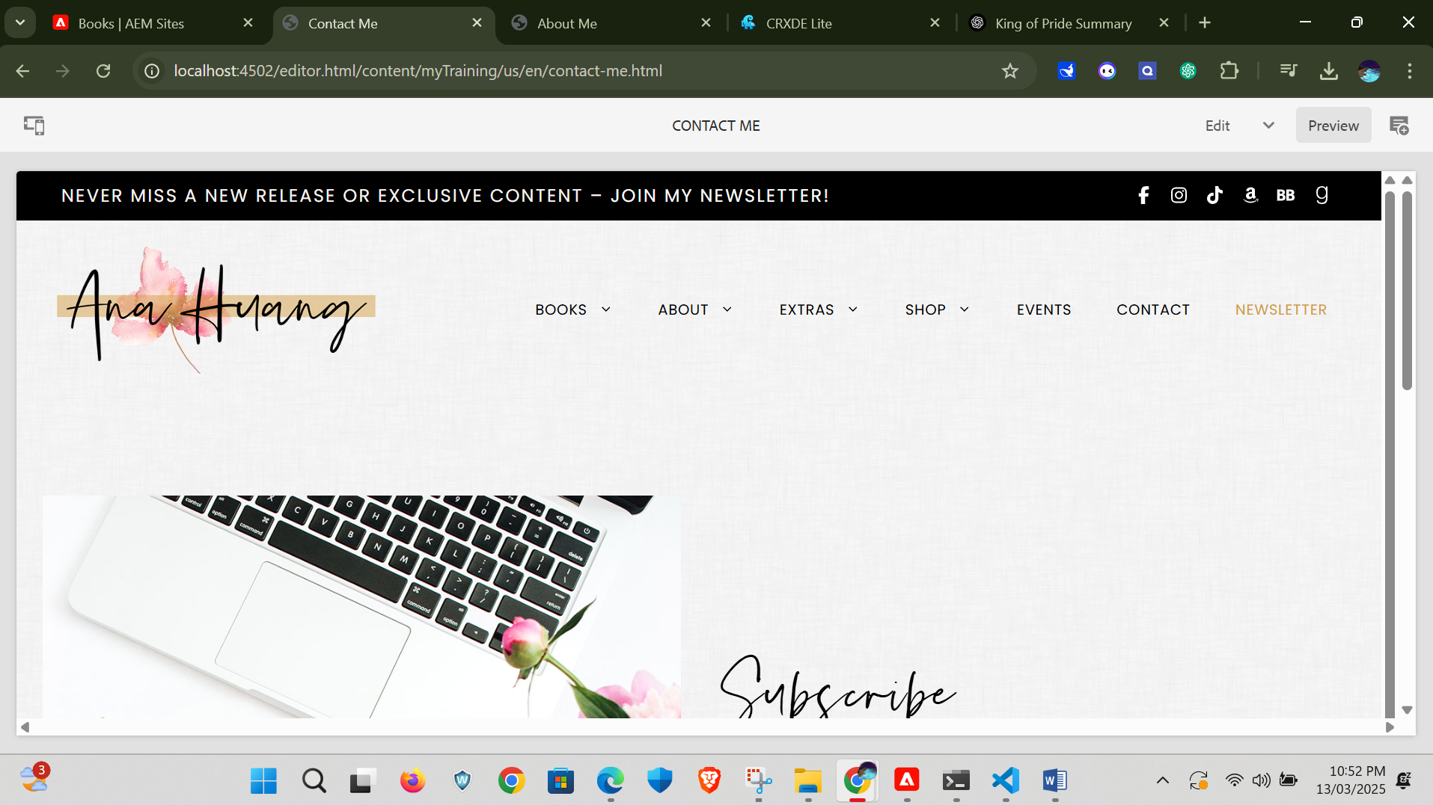

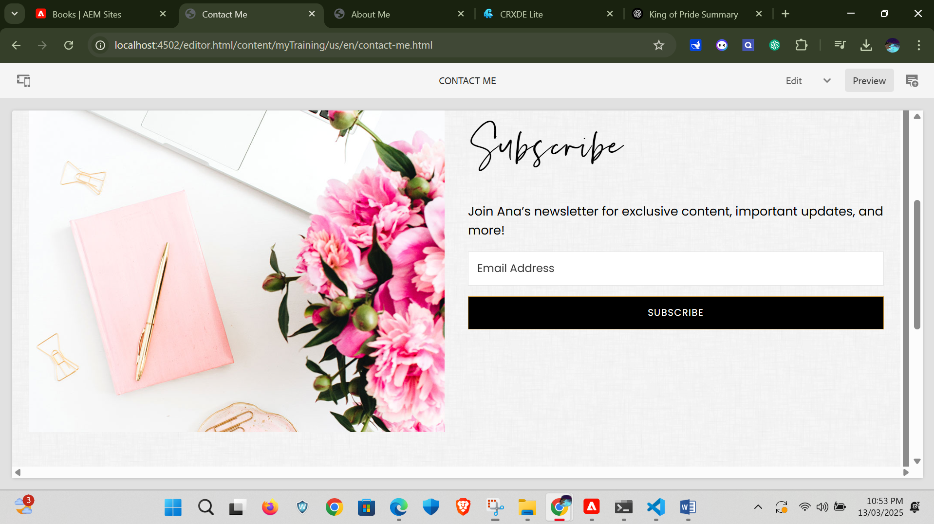

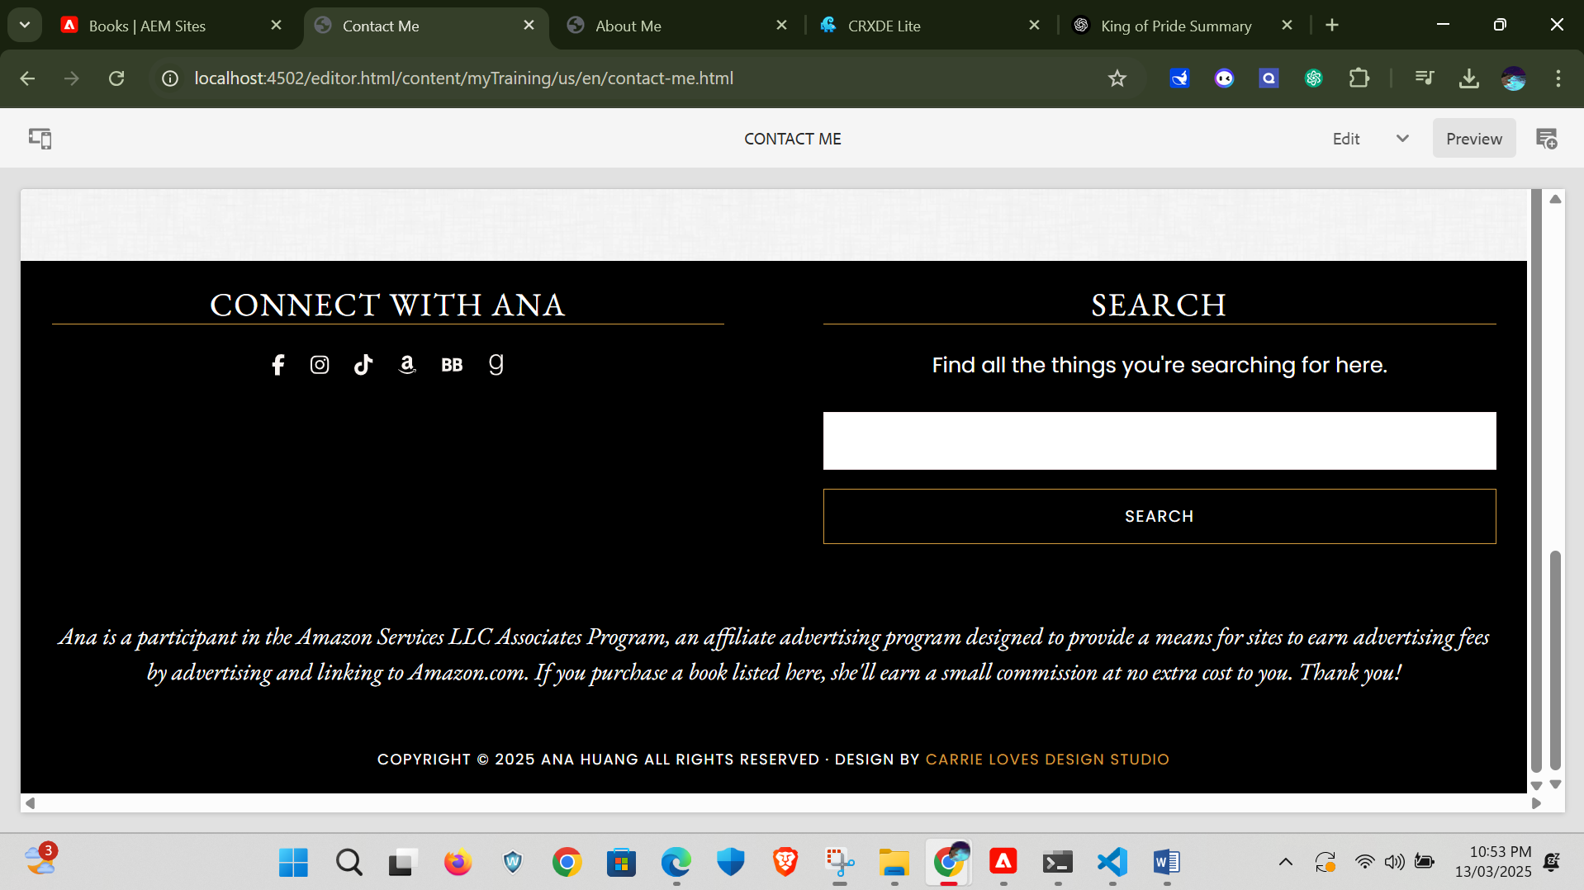

Next is the book page we created cards for each books with image, title and its description as it display all the books that were written by our author.

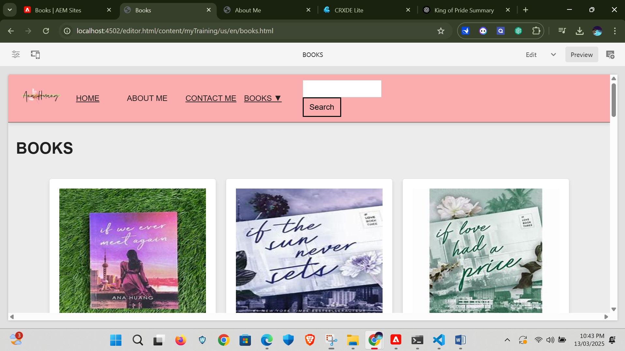

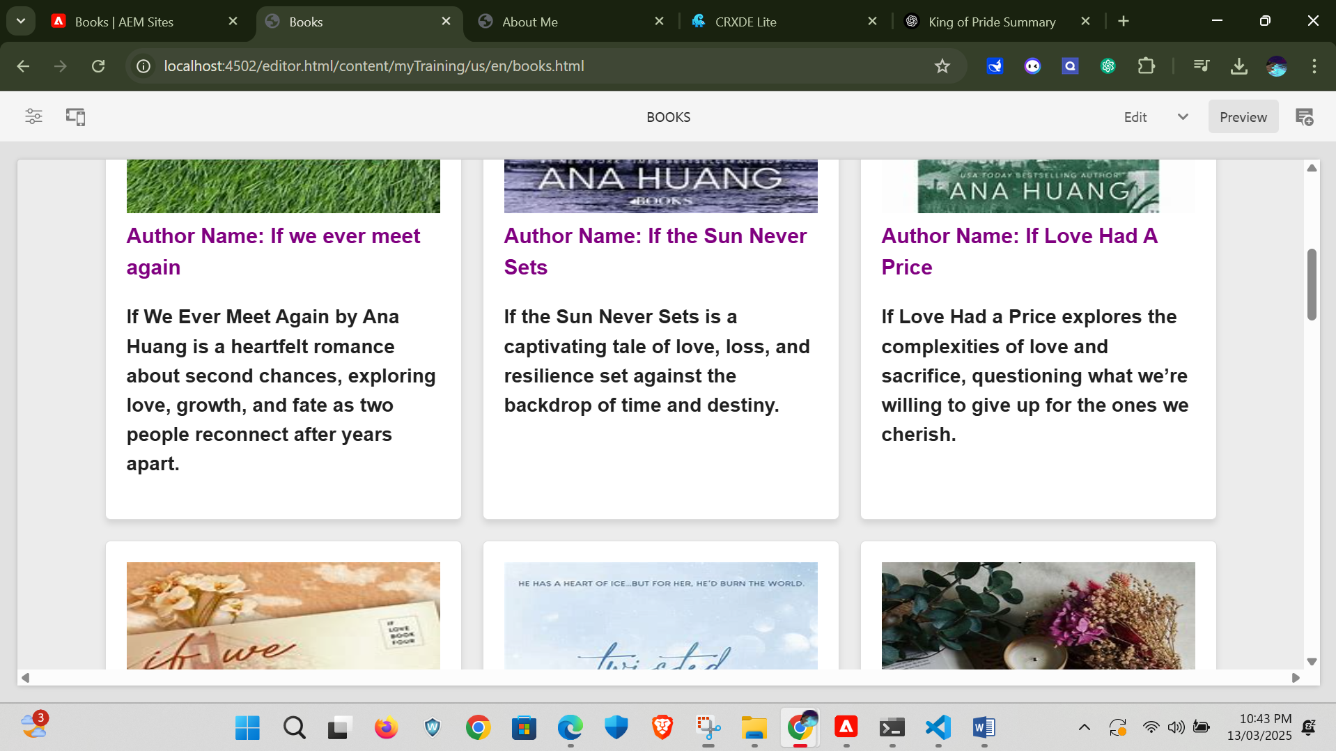

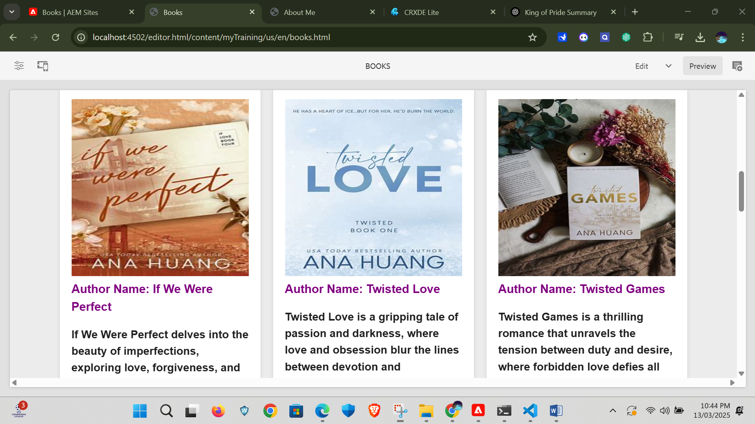

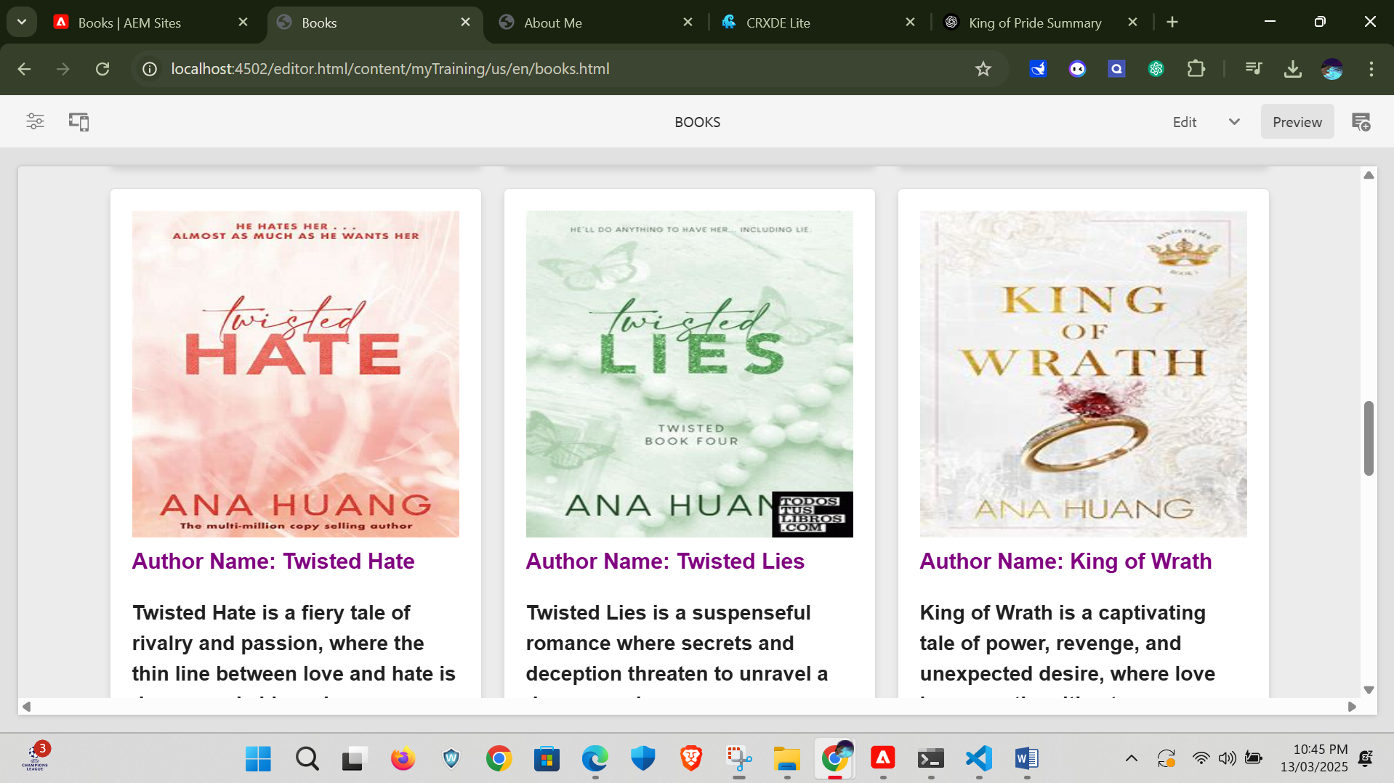

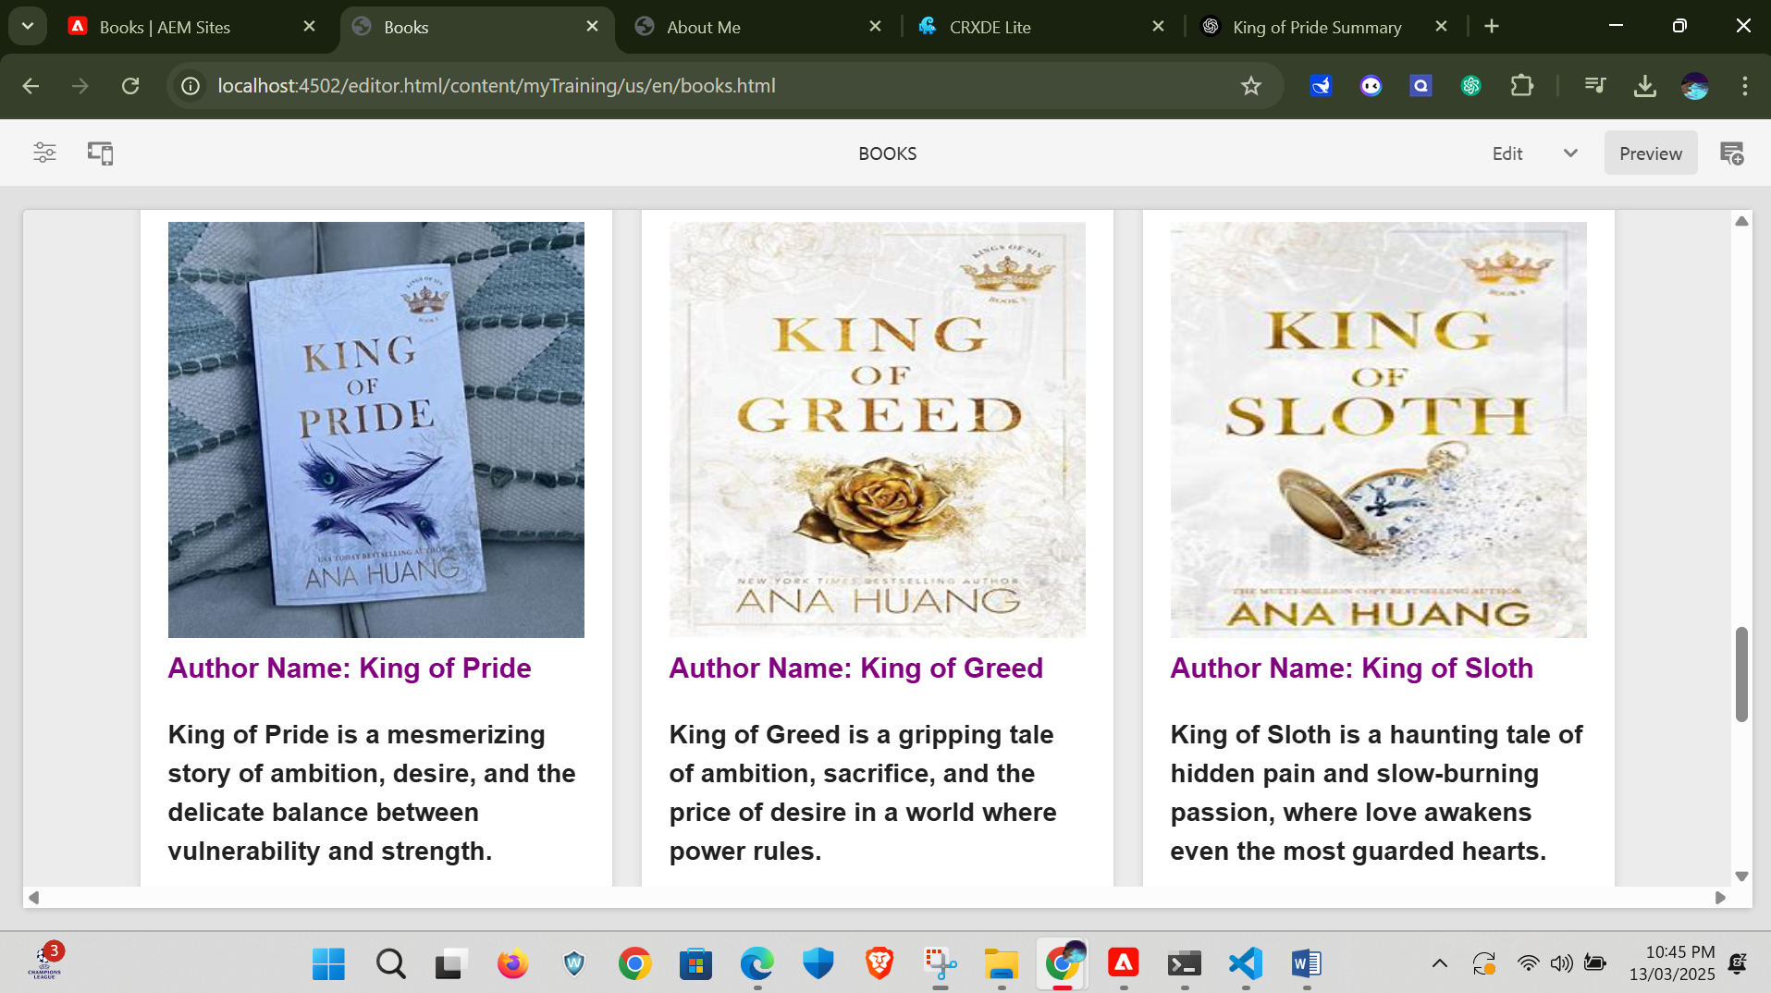

Here we can directly come to this book page by clicking the see resource link placed in the footer.

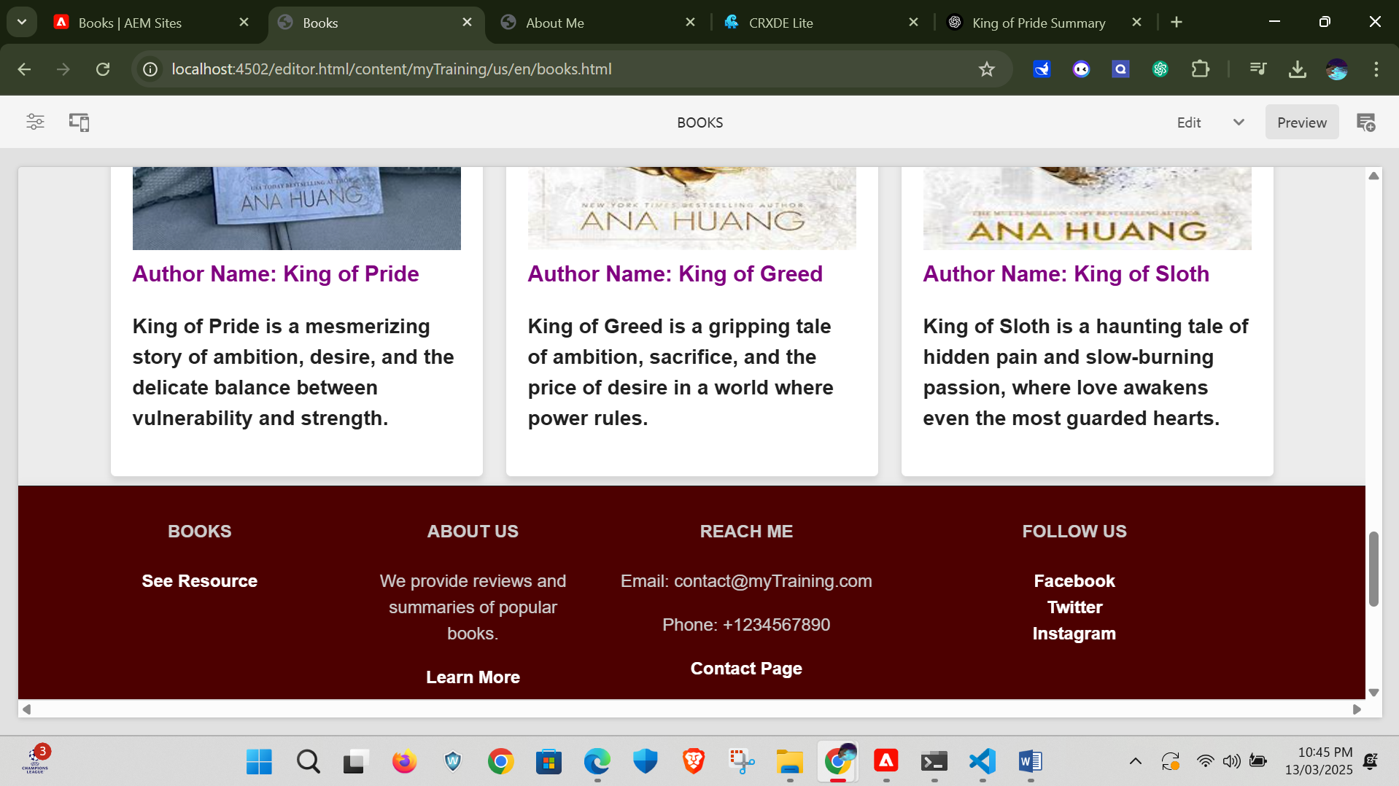

In the author menu we provide a dropdown option to the book menu in the header as it displays all the book link where it navigates to that particular book page where there is description or preview about that book.

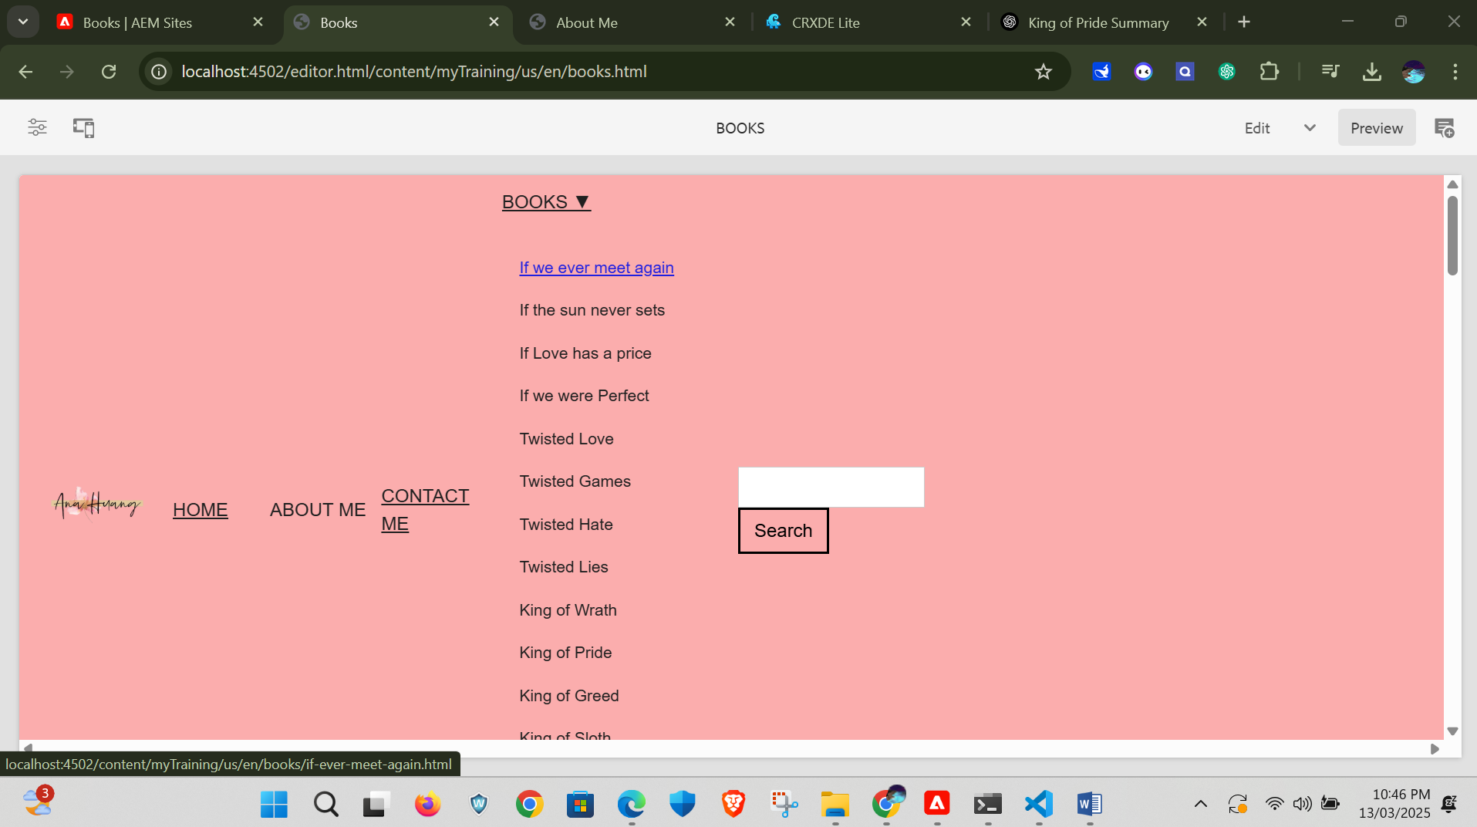

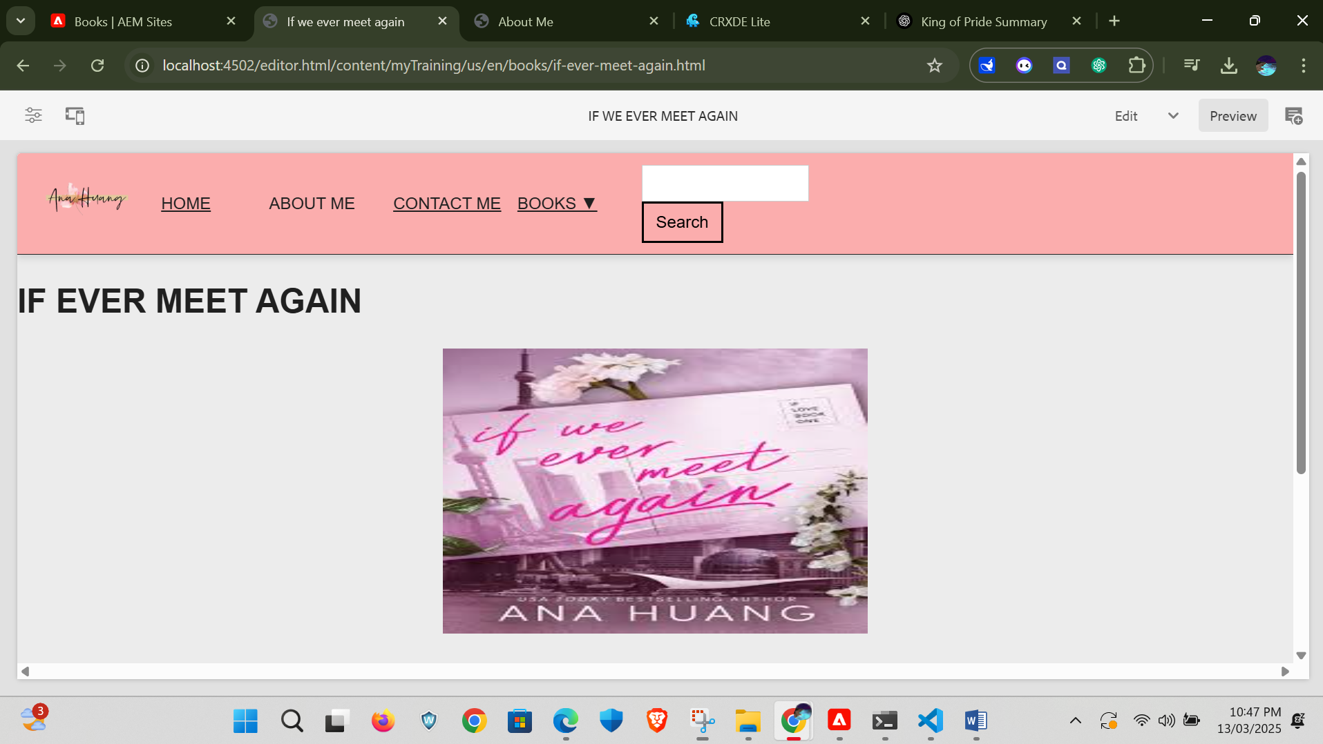

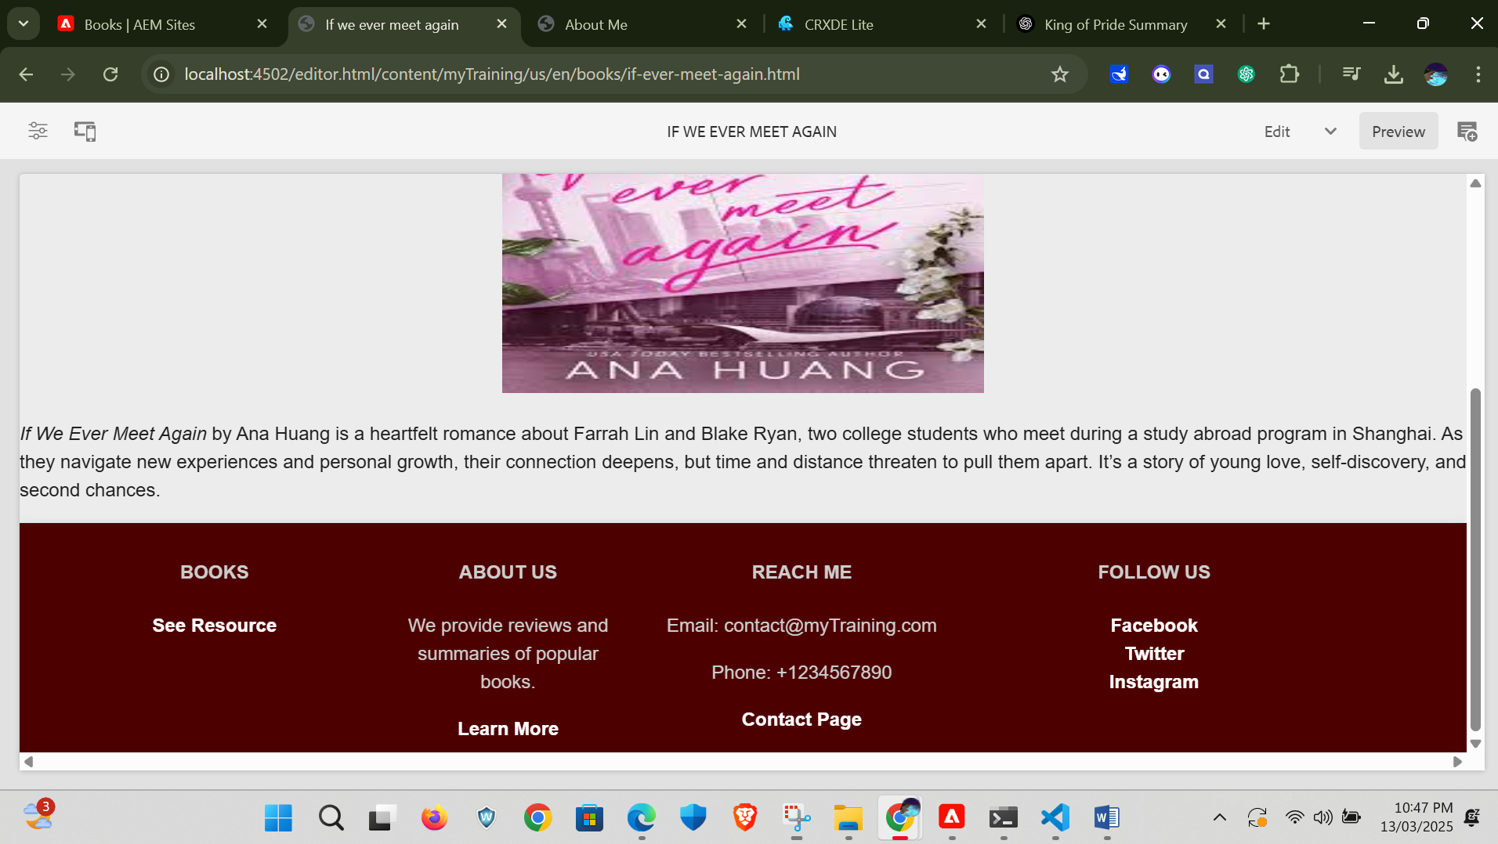

Here is the another example where we link the particular book link on drop down menu in the header section.

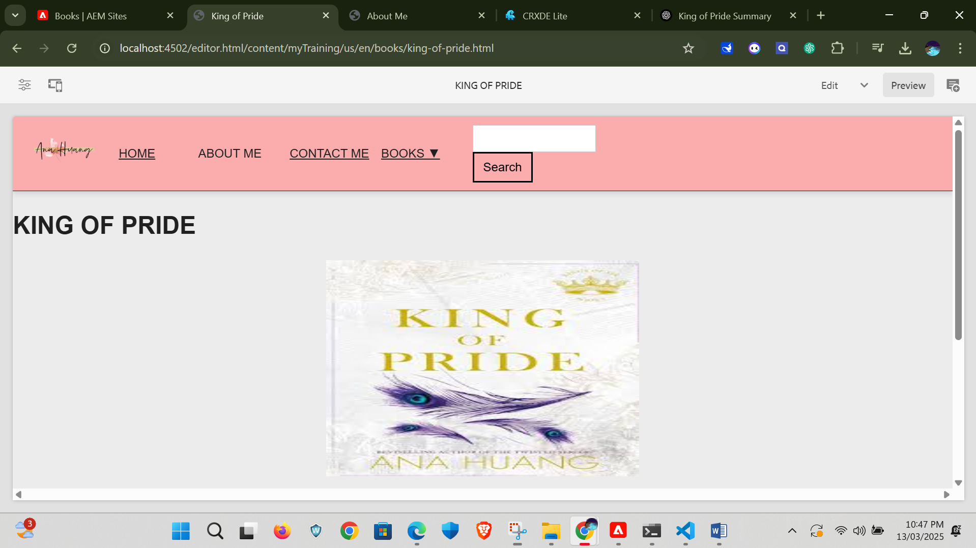

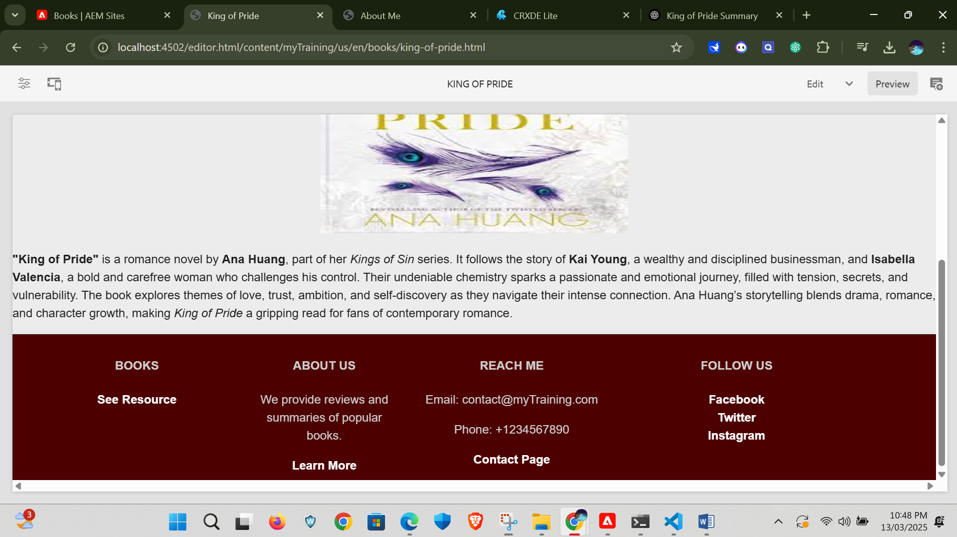

**Conclusion:**

Here we created a author’s portfolio was created with the reqiuirements that are all mentioned in the assignment successfully.